**Describe the purpose of Azure Policy**

How do you ensure that your resources stay compliant? Can you be alerted if a resource's configuration has changed?

Azure Policy is a service in Azure that enables you to create, assign, and manage policies that control or audit your resources. These policies enforce different rules across your resource configurations so that those configurations stay compliant with corporate standards.

**How does Azure Policy define policies?**

Azure Policy enables you to define both individual policies and groups of related policies, known as initiatives. Azure Policy evaluates your resources and highlights resources that aren't compliant with the policies you've created. Azure Policy can also prevent noncompliant resources from being created.

Azure Policies can be set at each level, enabling you to set policies on a specific resource, resource group, subscription, and so on. Additionally, Azure Policies are inherited, so if you set a policy at a high level, it will automatically be applied to all of the groupings that fall within the parent. For example, if you set an Azure Policy on a resource group, all resources created within that resource group will automatically receive the same policy.

Azure Policy comes with built-in policy and initiative definitions for Storage, Networking, Compute, Security Center, and Monitoring. For example, if you define a policy that allows only a certain size for the virtual machines (VMs) to be used in your environment, that policy is invoked when you create a new VM and whenever you resize existing VMs. Azure Policy also evaluates and monitors all current VMs in your environment, including VMs that were created before the policy was created.

In some cases, Azure Policy can automatically remediate noncompliant resources and configurations to ensure the integrity of the state of the resources. For example, if all resources in a certain resource group should be tagged with AppName tag and a value of "SpecialOrders," Azure Policy will automatically apply that tag if it is missing. However, you still retain full control of your environment. If you have a specific resource that you don’t want Azure Policy to automatically fix, you can flag that resource as an exception – and the policy won’t automatically fix that resource.

Azure Policy also integrates with Azure DevOps by applying any continuous integration and delivery pipeline policies that pertain to the pre-deployment and post-deployment phases of your applications.

**What are Azure Policy initiatives?**

An Azure Policy initiative is a way of grouping related policies together. The initiative definition contains all of the policy definitions to help track your compliance state for a larger goal.

For example, Azure Policy includes an initiative named Enable Monitoring in Azure Security Center. Its goal is to monitor all available security recommendations for all Azure resource types in Azure Security Center.

Under this initiative, the following policy definitions are included:

* Monitor unencrypted SQL Database in Security Center This policy monitors for unencrypted SQL databases and servers.
* Monitor OS vulnerabilities in Security Center This policy monitors servers that don't satisfy the configured OS vulnerability baseline.
* Monitor missing Endpoint Protection in Security Center This policy monitors for servers that don't have an installed endpoint protection agent.

In fact, the Enable Monitoring in Azure Security Center initiative contains over 100 separate policy definitions.

### Describe the purpose of resource locks.

**Resource Locks:**

A resource lock prevents resources from being accidentally deleted or changed.

Even with Azure role-based access control (Azure RBAC) policies in place, there's still a risk that people with the right level of access could delete critical cloud resources. Resource locks prevent resources from being deleted or updated, depending on the type of lock. Resource locks can be applied to individual resources, resource groups, or even an entire subscription. Resource locks are inherited, meaning that if you place a resource lock on a resource group, all of the resources within the resource group will also have the resource lock applied.

**Types of Resource Locks**

There are two types of resource locks, one that prevents users from deleting and one that prevents users from changing or deleting a resource.

* **Delete** means authorized users can still read and modify a resource, but they can't delete the resource.
* **ReadOnly** means authorized users can read a resource, but they can't delete or update the resource. Applying this lock is similar to restricting all authorized users to the permissions granted by the Reader role.

**How do I manage resource locks?**

You can manage resource locks from the Azure portal, PowerShell, the Azure CLI, or from an Azure Resource Manager template.

To view, add, or delete locks in the Azure portal, go to the Settings section of any resource's Settings pane in the Azure portal.

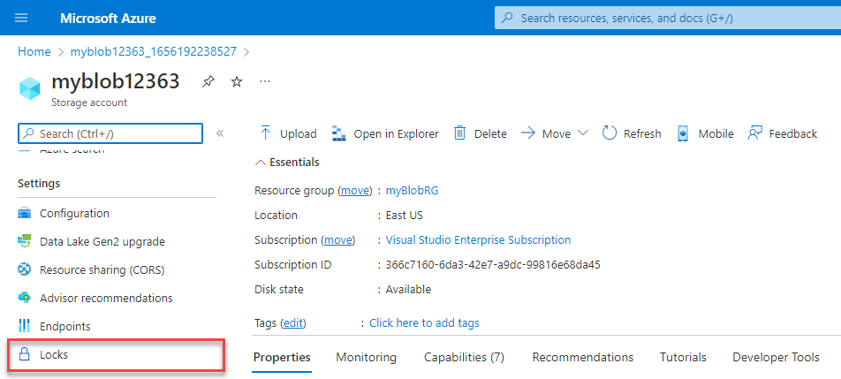

**How do I delete or change a locked resource?**

Although locking helps prevent accidental changes, you can still make changes by following a two-step process.

To modify a locked resource, you must first remove the lock. After you remove the lock, you can apply any action you have permissions to perform. Resource locks apply regardless of RBAC permissions. Even if you’re an owner of the resource, you must still remove the lock before you can perform the blocked activity.

The owner of a service has permissions to do anything with the resource. The owner can even delete the resource. Take the example of a VM. If the owner deletes the VM, MS will not be able to recover it. To avoid this, we can apply resource locks on resources.

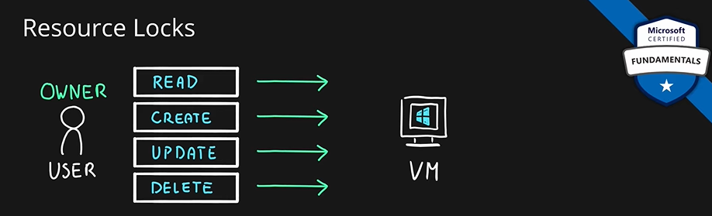

Resource lock of type delete, your resource cannot be deleted, even by the users who have owner permissions.

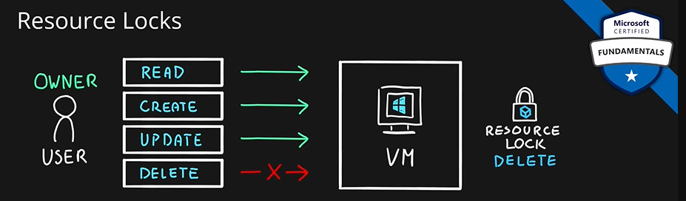

If owner wants to delete the VM, they first must remove the resource lock.

There is another type of resource lock, read only lock. If this lock is applied, then the resource can only be read. Even the owner can only do reading and not any other operation.

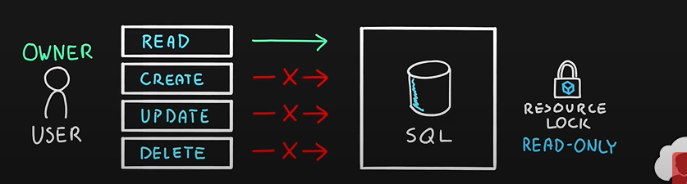

These locks help in preventing unwanted actions on azure resources while also maintaining all the privileges assigned to users.

You can create resource locks on resource levels and also on resource group levels.

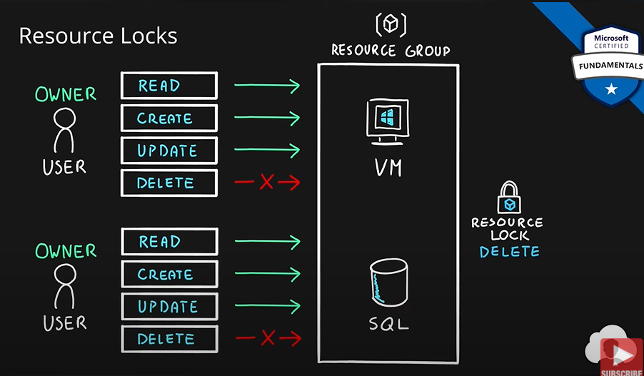

Resource lock of type delete is applied on resource group. Now, no resource inside this resource group can be deleted.

We already studied about the hierarchical structure in azure. You can apply resource locks on any level. Subscription level, resource group level and resource level.

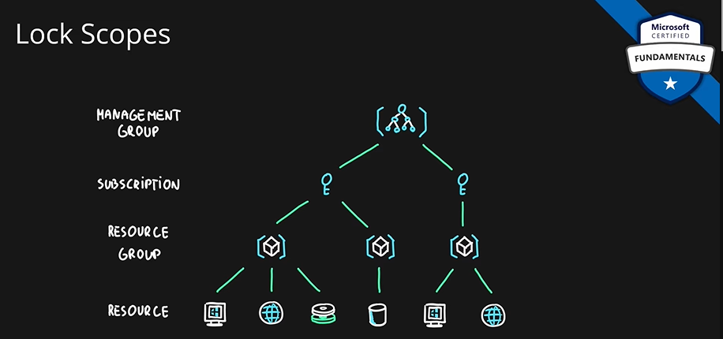

One common scenario for resource locks is for production apps. Resources locks are usually applied to VMs, storage accounts etc. which are being used by production apps to avoid accidental deletion production resources.

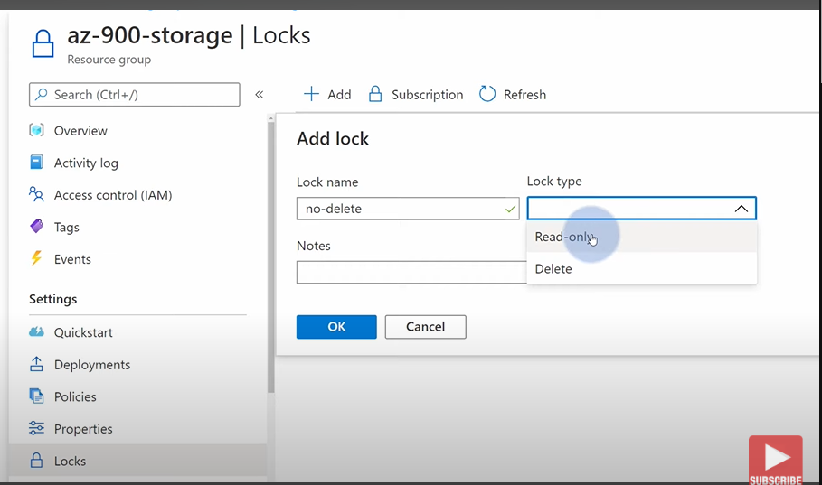

Only two roles and create and modify locks: **Owner and user access administrator.**

There are only two locks: **Delete and Read-only.**

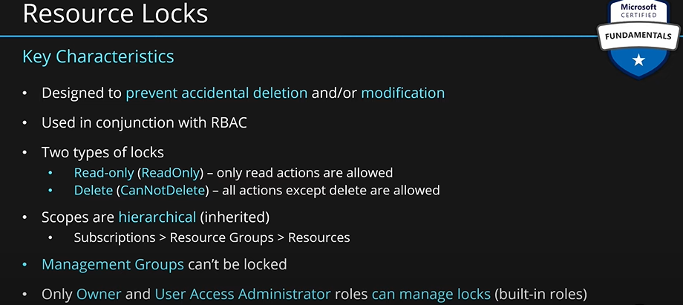

## Describe features and tools for managing and deploying Azure resources.

### Describe the Azure portal.

**Azure Portal:**

The Azure portal is a web-based, unified console that provides an alternative to command-line tools. With the Azure portal, you can manage your Azure subscription by using a graphical user interface. You can:

* Build, manage, and monitor everything from simple web apps to complex cloud deployments.
* Create custom dashboards for an organized view of resources.
* Configure accessibility options for an optimal experience.

The Azure portal is designed for resiliency and continuous availability. It maintains a presence in every Azure datacenter. This configuration makes the Azure portal resilient to individual datacenter failures and avoids network slowdowns by being close to users. The Azure portal updates continuously and requires no downtime for maintenance activities.

Allows you to manage all the azure resources. Link is portal.azure.com

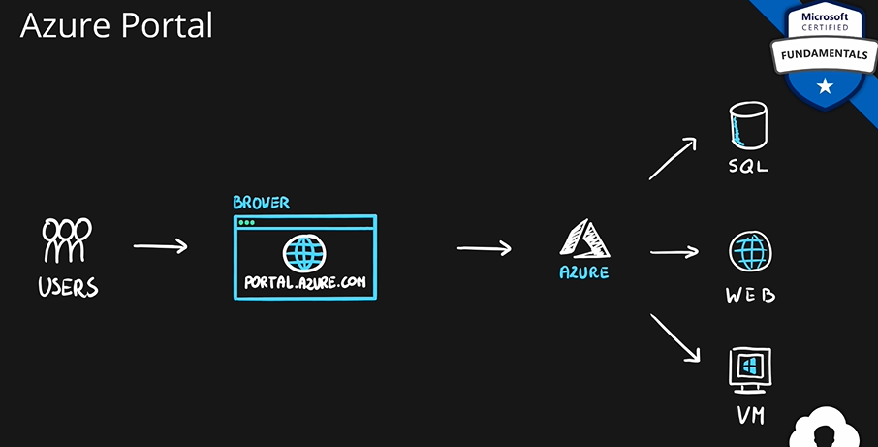

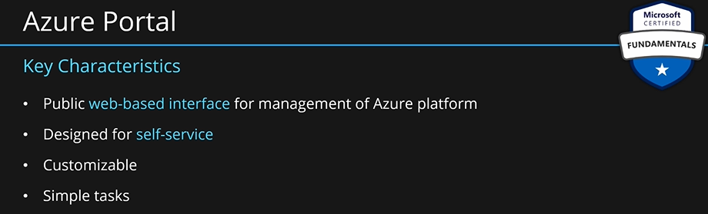

It is built for smaller tasks. It should not be used if you want to do big deployments.

### Describe Azure Cloud Shell, including Azure Command-Line Interface (CLI) and Azure PowerShell

**Azure Power Shell:**

Azure PowerShell is a shell with which developers, DevOps, and IT professionals can run commands called command-lets (cmdlets). These commands call the Azure REST API to perform management tasks in Azure. Cmdlets can be run independently to handle one-off changes, or they may be combined to help orchestrate complex actions such as:

* The routine setup, teardown, and maintenance of a single resource or multiple connected resources.
* The deployment of an entire infrastructure, which might contain dozens or hundreds of resources, from imperative code.
* Capturing the commands in a script makes the process repeatable and automatable.

In addition to be available via Azure Cloud Shell, you can install and configure Azure PowerShell on Windows, Linux, and Mac platforms.

Azure can be accessed through terminal. This works for windows, Linux and mac OS. You can connect to azure using terminal and do work through commands.

This module is created for automation. It uses a very strong scripting language called PowerShell. You can create very complex logics using scripts.

PowerShell is best for developers already working/familiar with windows-based system. Because they will already be familiar with PowerShell.

PS = PowerShell

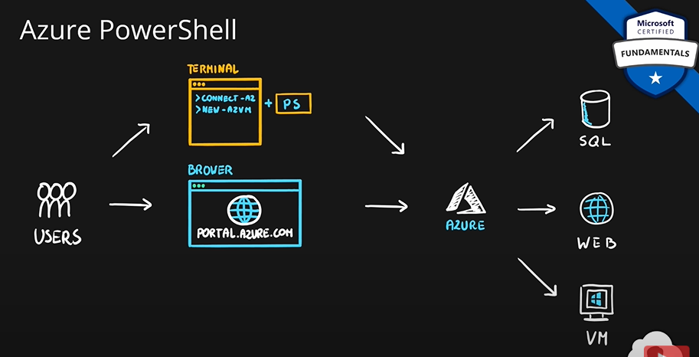

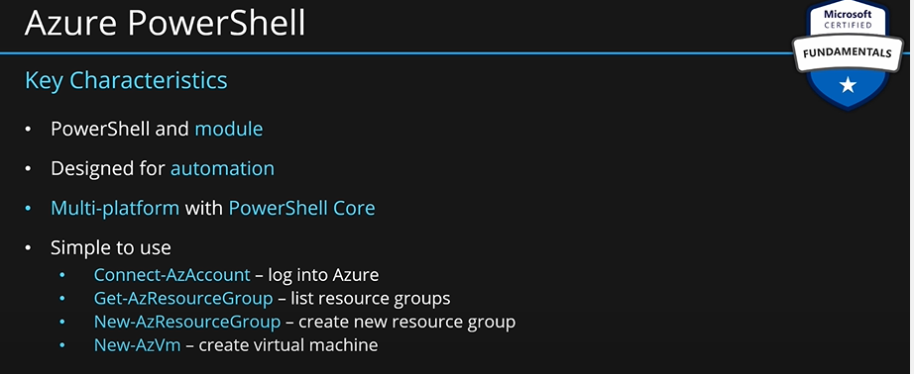

**Azure CLI (Command Line Interface):**

The Azure CLI is functionally equivalent to Azure PowerShell, with the primary difference being the syntax of commands. **While Azure PowerShell uses PowerShell commands, the Azure CLI uses Bash commands.**

The Azure CLI provides the same benefits of handling discrete tasks or orchestrating complex operations through code. It’s also installable on Windows, Linux, and Mac platforms, as well as through Azure Cloud Shell.

Due to the similarities in capabilities and access between Azure PowerShell and the Bash based Azure CLI, it mainly comes down to which language you’re most familiar with.

Same as PowerShell, you can connect to azure using the terminal. You can also manage azure resource just like PowerShell. It is also created for automation. It is available on any OS.

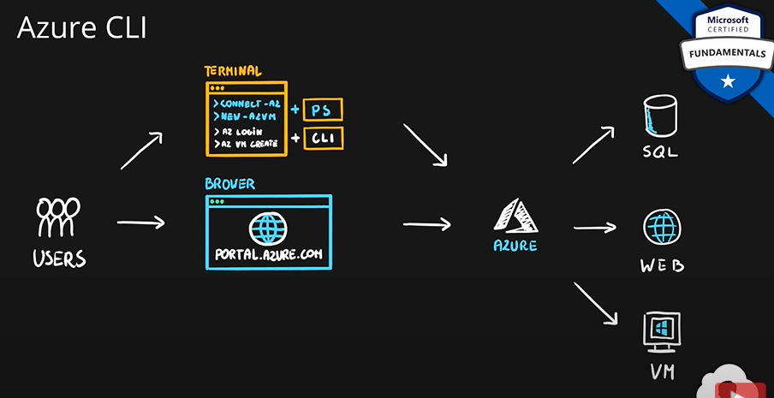

CLI is tool for native terminal. So, depending on which OS you are using, you will have different scripting capabilities.

Most of the times, you can use either CLI or PowerShell to manage azure. They are same mostly.

**Azure Cloud Shell:**

Azure Cloud Shell is a browser-based shell tool that allows you to create, configure, and manage Azure resources using a shell. Azure Cloud Shell support both Azure PowerShell and the Azure Command Line Interface (CLI), which is a Bash shell.

You can access Azure Cloud Shell via the Azure portal by selecting the Cloud Shell icon:

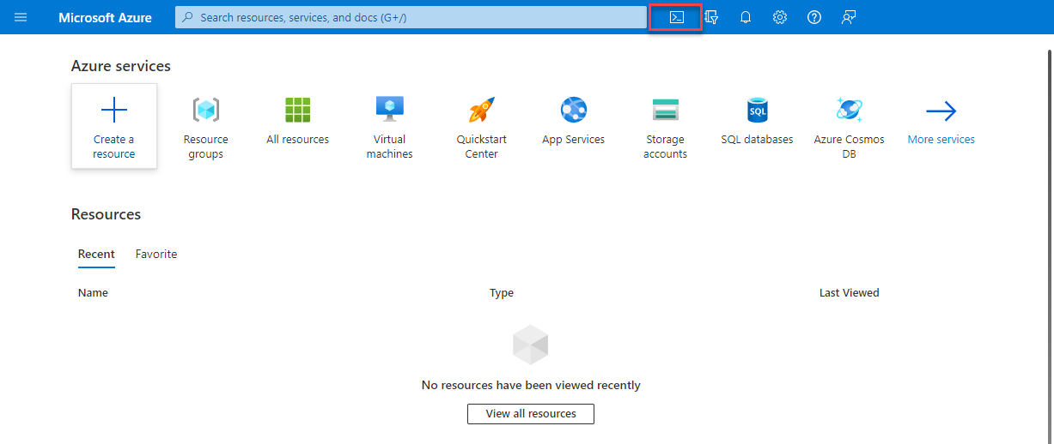

Azure Cloud Shell has several features that make it a unique offering to support you in managing Azure. Some of those features are:

* It is a browser-based shell experience, with no local installation or configuration required.
* It is authenticated to your Azure credentials, so when you log in it inherently knows who you are and what permissions you have.
* You choose the shell you’re most familiar with; Azure Cloud Shell supports both Azure PowerShell and the Azure CLI (which uses Bash).

All these tools work inside the user machine. So, the user has to install these tools in their machine. But sometimes the user does not have the permission to install these tools on the machine. To solve this problem, MS provides an environment where all these tools are already installed and are up to date. This environment is called **cloud shell.** User can access this through web browser using [shell.azure.com](https://go.microsoft.com/fwlink/?linkid=2244268)

It is based on ubuntu container. You can use PowerShell or CLI, whichever you prefer. This environment is completely free. With this, you don’t need to install anything on your local machine.

There is a mobile app as well which you can use to connect to cloud shell. You can also go to cloud shell from azure portal.

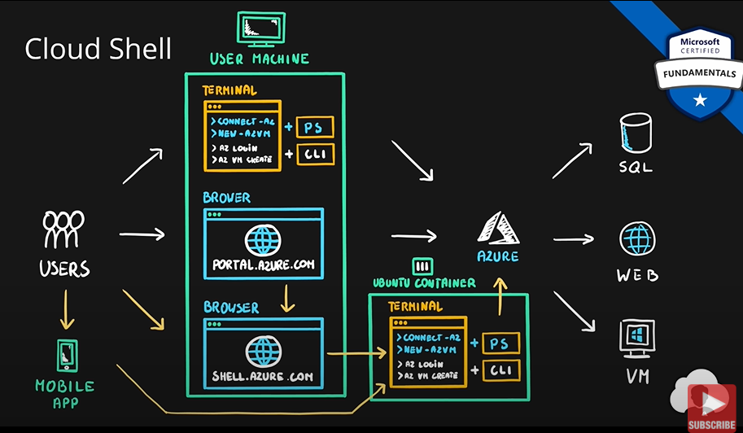

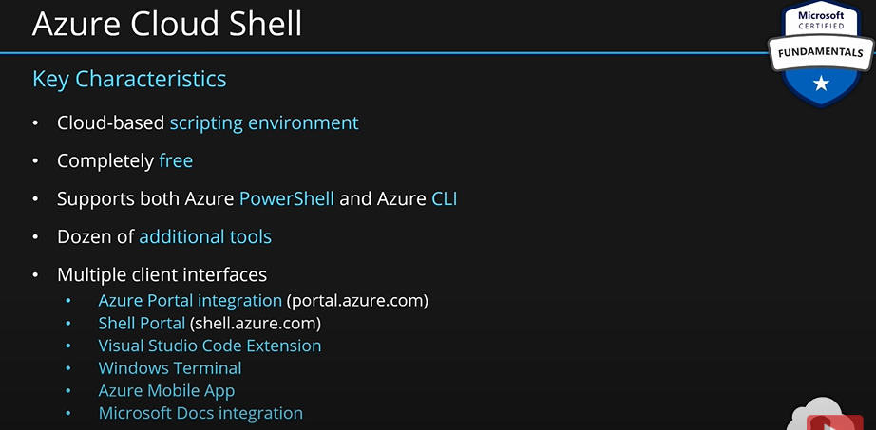

**Summary:**

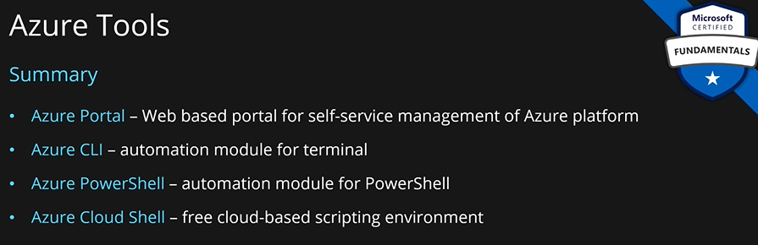

### Describe the purpose of Azure Arc.

**Describe the purpose of Azure Arc:**

Managing hybrid and multi-cloud environments can rapidly get complicated. Azure provides a host of tools to provision, configure, and monitor Azure resources. What about the on-premises resources in a hybrid configuration or the cloud resources in a multi-cloud configuration?

In utilizing Azure Resource Manager (ARM), Arc lets you extend your Azure compliance and monitoring to your hybrid and multi-cloud configurations. Azure Arc simplifies governance and management by delivering a consistent multi-cloud and on-premises management platform.

**Azure Arc provides a centralized, unified way to:**

* Manage your entire environment together by projecting your existing non-Azure resources into ARM.
* Manage multi-cloud and hybrid virtual machines, Kubernetes clusters, and databases as if they are running in Azure.
* Use familiar Azure services and management capabilities, regardless of where they live.
* Continue using traditional ITOps while introducing DevOps practices to support new cloud and native patterns in your environment.
* Configure custom locations as an abstraction layer on top of Azure Arc-enabled Kubernetes clusters and cluster extensions.

**What can Azure Arc do outside of Azure?**

Currently, Azure Arc allows you to manage the following resource types hosted outside of Azure:

* Servers
* Kubernetes clusters
* Azure data services
* SQL Server
* Virtual machines (preview)

### Describe Azure Resource Manager (ARM) and ARM templates.

**Describe Azure Resource Manager and Azure ARM templates:**

Azure Resource Manager (ARM) is the deployment and management service for Azure. It provides a management layer that enables you to create, update, and delete resources in your Azure account. Anytime you do anything with your Azure resources, ARM is involved.

When a user sends a request from any of the Azure tools, APIs, or SDKs, ARM receives the request. ARM authenticates and authorizes the request. Then, ARM sends the request to the Azure service, which takes the requested action. **You see consistent results and capabilities in all the different tools because all requests are handled through the same API.**

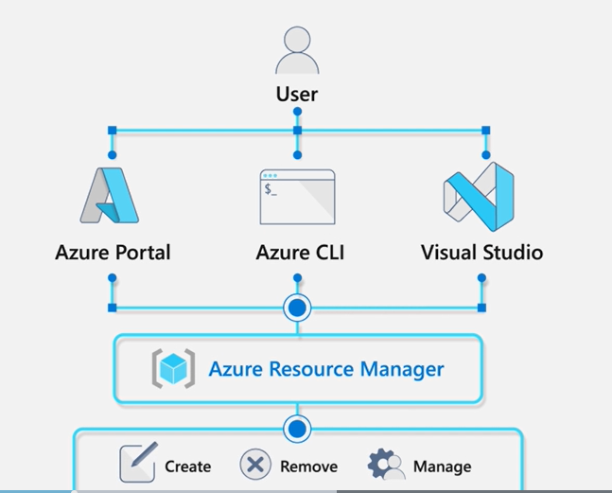

**Azure Resource Manager benefits**

**With Azure Resource Manager, you can:**

* Manage your infrastructure through declarative templates rather than scripts. A Resource Manager template is a JSON file that defines what you want to deploy to Azure.
* Deploy, manage, and monitor all the resources for your solution as a group, rather than handling these resources individually.
* Re-deploy your solution throughout the development life cycle and have confidence your resources are deployed in a consistent state.
* Define the dependencies between resources, so they're deployed in the correct order.
* Apply access control to all services because RBAC is natively integrated into the management platform.
* Apply tags to resources to logically organize all the resources in your subscription.
* Clarify your organization's billing by viewing costs for a group of resources that share the same tag.

### Describe infrastructure as code (IaC).

**Infrastructure as code**

Infrastructure as code is a concept where you manage your infrastructure as lines of code. At an introductory level, it's things like using Azure Cloud Shell, Azure PowerShell, or the Azure CLI to manage and configure your resources. As you get more comfortable in the cloud, you can use the infrastructure as code concept to manage entire deployments using repeatable templates and configurations. **ARM templates and Bicep** are two examples of using infrastructure as code with the Azure Resource Manager to maintain your environment.

**ARM templates:**

By using ARM templates, you can describe the resources you want to use in a declarative JSON format. With an ARM template, the deployment code is verified before any code is run. This ensures that the resources will be created and connected correctly. The template then orchestrates the creation of those resources in parallel. That is, if you need 50 instances of the same resource, all 50 instances are created at the same time.

Ultimately, the developer, DevOps professional, or IT professional needs only to define the desired state and configuration of each resource in the ARM template, and the template does the rest. Templates can even execute PowerShell and Bash scripts before or after the resource has been set up.

**Benefits of using ARM templates**

**ARM templates provide many benefits when planning for deploying Azure resources. Some of those benefits include:**

* **Declarative syntax:** ARM templates allow you to create and deploy an entire Azure infrastructure declaratively. Declarative syntax means you declare what you want to deploy but don’t need to write the actual programming commands and sequence to deploy the resources.
* **Repeatable results**: Repeatedly deploy your infrastructure throughout the development lifecycle and have confidence your resources are deployed in a consistent manner. You can use the same ARM template to deploy multiple dev/test environments, knowing that all the environments are the same.
* **Orchestration**: You don't have to worry about the complexities of ordering operations. Azure Resource Manager orchestrates the deployment of interdependent resources, so they're created in the correct order. When possible, Azure Resource Manager deploys resources in parallel, so your deployments finish faster than serial deployments. You deploy the template through one command, rather than through multiple imperative commands.
* **Modular files:** You can break your templates into smaller, reusable components and link them together at deployment time. You can also nest one template inside another template. For example, you could create a template for a VM stack, and then nest that template inside of templates that deploy entire environments, and that VM stack will consistently be deployed in each of the environment templates.
* **Extensibility**: With deployment scripts, you can add PowerShell or Bash scripts to your templates. The deployment scripts extend your ability to set up resources during deployment. A script can be included in the template or stored in an external source and referenced in the template. Deployment scripts give you the ability to complete your end-to-end environment setup in a single ARM template.

**Bicep**

Bicep is a language that uses declarative syntax to deploy Azure resources. A Bicep file defines the infrastructure and configuration. Then, ARM deploys that environment based on your Bicep file. While similar to an ARM template, which is written in JSON, Bicep files tend to use a simpler, more concise style.

**Some benefits of Bicep are:**

* Support for all resource types and API versions: Bicep immediately supports all preview and GA versions for Azure services. As soon as a resource provider introduces new resource types and API versions, you can use them in your Bicep file. You don't have to wait for tools to be updated before using the new services.
* Simple syntax: When compared to the equivalent JSON template, Bicep files are more concise and easier to read. Bicep requires no previous knowledge of programming languages. Bicep syntax is declarative and specifies which resources and resource properties you want to deploy.
* Repeatable results: Repeatedly deploy your infrastructure throughout the development lifecycle and have confidence your resources are deployed in a consistent manner. Bicep files are idempotent, which means you can deploy the same file many times and get the same resource types in the same state. You can develop one file that represents the desired state, rather than developing lots of separate files to represent updates.
* Orchestration: You don't have to worry about the complexities of ordering operations. Resource Manager orchestrates the deployment of interdependent resources, so they're created in the correct order. When possible, Resource Manager deploys resources in parallel, so your deployments finish faster than serial deployments. You deploy the file through one command, rather than through multiple imperative commands.
* Modularity: You can break your Bicep code into manageable parts by using modules. The module deploys a set of related resources. Modules enable you to reuse code and simplify development. Add the module to a Bicep file anytime you need to deploy those resources.

## Describe monitoring tools in Azure.

### Describe the purpose of Azure Advisor.

**Azure Advisor:**

Azure Advisor evaluates your Azure resources and makes recommendations to help improve reliability, security, and performance, achieve operational excellence, and reduce costs. Azure Advisor is designed to help you save time on cloud optimization. The recommendation service includes suggested actions you can take right away, postpone, or dismiss.

The recommendations are available via the Azure portal and the API, and you can set up notifications to alert you to new recommendations.

When you’re in the Azure portal, the Advisor dashboard displays personalized recommendations for all your subscriptions. You can use filters to select recommendations for specific subscriptions, resource groups, or services. The recommendations are divided into five categories:

* **Reliability** is used to ensure and improve the continuity of your business-critical applications.
* **Security** is used to detect threats and vulnerabilities that might lead to security breaches.
* **Performance** is used to improve the speed of your applications.
* **Operational Excellence** is used to help you achieve process and workflow efficiency, resource manageability, and deployment best practices.
* **Cost** is used to optimize and reduce your overall Azure spending.

**The following image shows the Azure Advisor dashboard.**

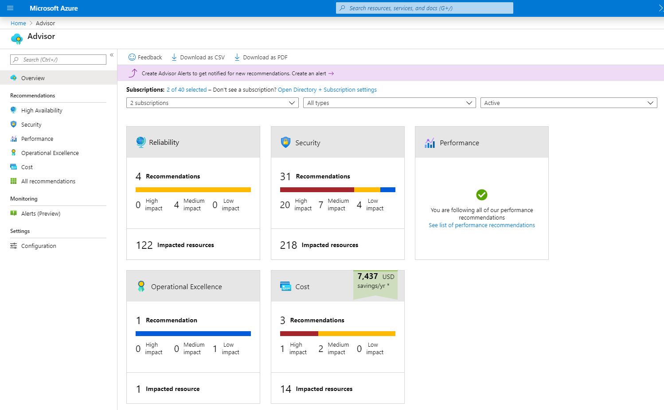

Whenever we want to set up some services in cloud such as web servers, SQL DBs, VMs etc. We might not be experts in these services. We may miss some critical configurations and end up with more cost, less reliability, less security or less performance. Azure advisor provides us with recommendations regarding services which helps us with many parameters such as security, performance, reliability, cost, operational excellence etc. You can also opt in to get notifications whenever there are new recommendations.

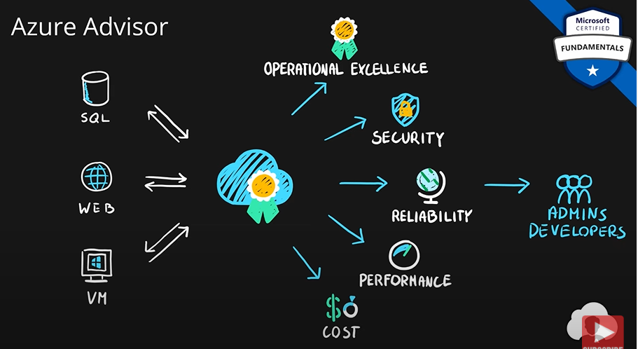

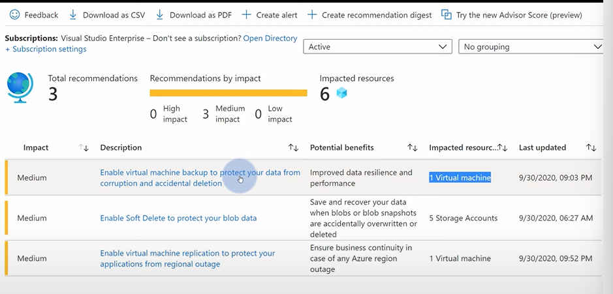

You can just click on the description and do the action. You don’t have to go through many steps to act on a recommendation.

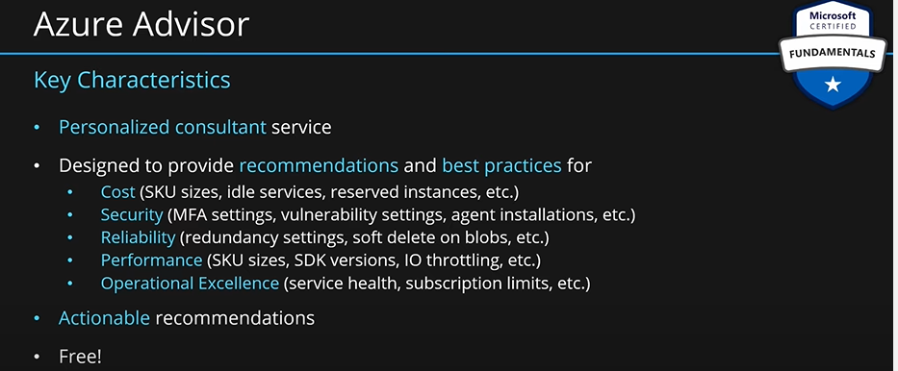

### Describe Azure Service Health.

**Describe Azure Service Health:**

Microsoft Azure provides a global cloud solution to help you manage your infrastructure needs, reach your customers, innovate, and adapt rapidly. Knowing the status of the global Azure infrastructure and your individual resources could seem like a daunting task. Azure Service Health helps you keep track of Azure resource, both your specifically deployed resources and the overall status of Azure. Azure service health does this by combining three different Azure services:

* **Azure Status** is a broad picture of the status of Azure globally. Azure status informs you of service outages in Azure on the Azure Status page. The page is a global view of the health of all Azure services across all Azure regions. It’s a good reference for incidents with widespread impact.
* **Service Health** provides a narrower view of Azure services and regions. It focuses on the Azure services and regions you’re using. This is the best place to look for service impacting communications about outages, planned maintenance activities, and other health advisories because the authenticated Service Health experience knows which services and resources you currently use. You can even set up Service Health alerts to notify you when service issues, planned maintenance, or other changes may affect the Azure services and regions you use.
* **Resource Health** is a tailored view of your actual Azure resources. It provides information about the health of your individual cloud resources, such as a specific virtual machine instance. Using Azure Monitor, you can also configure alerts to notify you of availability changes to your cloud resources.

By using Azure status, service health, and Resource health, Azure Service Health gives you a complete view of your Azure environment-all the way from the global status of Azure services and regions down to specific resources. Additionally, historical alerts are stored and accessible for later review. Something you initially thought was a simple anomaly that turned into a trend, can readily be reviewed and investigated thanks to the historical alerts.

Finally, in the event that a workload you’re running is impacted by an event, Azure Service Health provides links to support.

**Describe Azure Monitor:**

Azure Monitor is a platform for collecting data on your resources, analyzing that data, visualizing the information, and even acting on the results. Azure Monitor can monitor Azure resources, your on-premises resources, and even multi-cloud resources like virtual machines hosted with a different cloud provider.

The following diagram illustrates just how comprehensive Azure Monitor is:

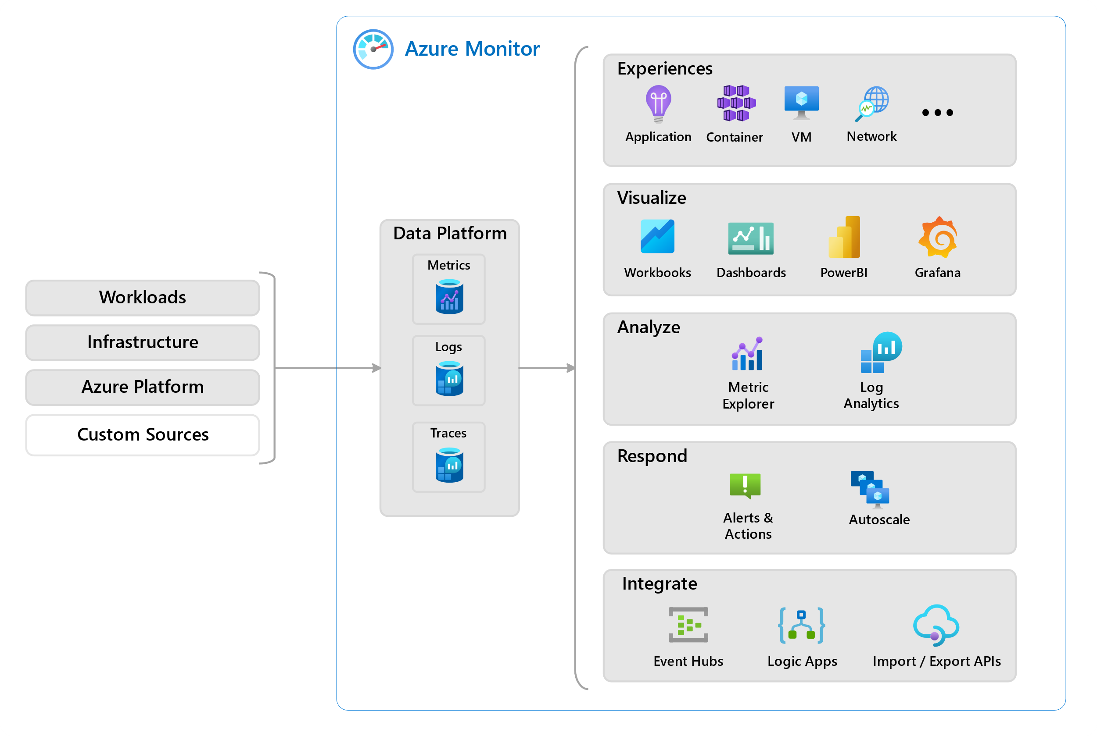

On the left is a list of the sources of logging and metric data that can be collected at every layer in your application architecture, from application to operating system and network.

In the center, the logging and metric data are stored in central repositories.

On the right, the data is used in several ways. You can view real-time and historical performance across each layer of your architecture or aggregated and detailed information. The data is displayed at different levels for different audiences. You can view high-level reports on the Azure Monitor Dashboard or create custom views by using Power BI and Kusto queries.

Additionally, you can use the data to help you react to critical events in real time, through alerts delivered to teams via SMS, email, and so on. Or you can use thresholds to trigger autoscaling functionality to scale to meet the demand.

### Describe Azure Monitor, including Log Analytics, Azure Monitor alerts, and Application Insights.

**Azure Log Analytics**

Azure Log Analytics is the tool in the Azure portal where you’ll write and run log queries on the data gathered by Azure Monitor. Log Analytics is a robust tool that supports both simple, complex queries, and data analysis. You can write a simple query that returns a set of records and then use features of Log Analytics to sort, filter, and analyze the records. You can write an advanced query to perform statistical analysis and visualize the results in a chart to identify a particular trend. Whether you work with the results of your queries interactively or use them with other Azure Monitor features such as log query alerts or workbooks, Log Analytics is the tool that you're going to use to write and test those queries.

**Azure Monitor Alerts**

Azure Monitor Alerts are an automated way to stay informed when Azure Monitor detects a threshold being crossed. You set the alert conditions, the notification actions, and then Azure Monitor Alerts notifies when an alert is triggered. Depending on your configuration, Azure Monitor Alerts can also attempt corrective action.

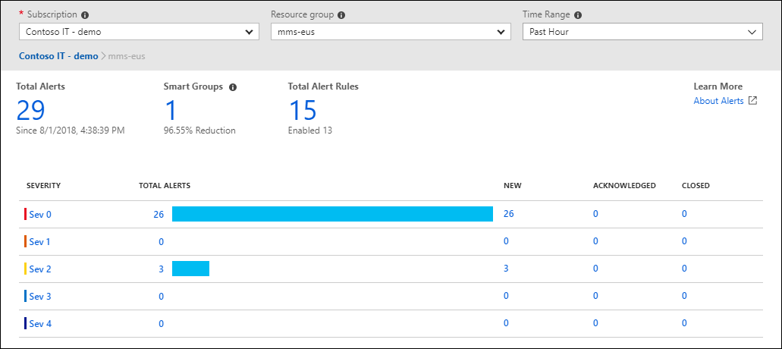

Alerts can be set up to monitor the logs and trigger on certain log events, or they can be set to monitor metrics and trigger when certain metrics are crossed. For example, you could set a metric-based alert up to notify you when the CPU usage on a virtual machine exceeded 80%. Alert rules based on metrics provide near real time alerts based on numeric values. Rules based on logs allow for complex logic across data from multiple sources.

Azure Monitor Alerts use action groups to configure who to notify and what action to take. An action group is simply a collection of notification and action preferences that you associate with one or multiple alerts. Azure Monitor, Service Health, and Azure Advisor all use actions groups to notify you when an alert has been triggered.

**Application Insights:**

Application Insights, an Azure Monitor feature, monitors your web applications. Application Insights is capable of monitoring applications that are running in Azure, on-premises, or in a different cloud environment.

There are two ways to configure Application Insights to help monitor your application. You can either install an SDK in your application, or you can use the Application Insights agent. The Application Insights agent is supported in C#.NET, VB.NET, Java, JavaScript, Node.js, and Python.

Once Application Insights is up and running, you can use it to monitor a broad array of information, such as:

* Request rates, response times, and failure rates.
* Dependency rates, response times, and failure rates, to show whether external services are slowing down performance.
* Page views and load performance reported by users' browsers.
* AJAX calls from web pages, including rates, response times, and failure rates.
* User and session counts
* Performance counters from Windows or Linux server machines, such as CPU, memory, and network usage

Not only does Application Insights help you monitor the performance of your application, but you can also configure it to periodically send synthetic requests to your application, allowing you to check the status and monitor your application even during periods of low activity.

# Extra Topics.

## Azure Load Balancer.

Load Balancer means distribution of traffic across multiple resources. If we have two VMs, we can put a load balancer in front of them and evenly distribute traffic between them. If might need to do this for scalability. Especially, when we do horizontal scaling (scaling out). Or we can also use it for availability. If these VMs are premium SSD machines, MS will provide 99.9% (three nines) of SLA. If we put these machines into different availability zones, then we can get 99.99% (four nines) of SLA. Load balancer between them will check the health of these VMs, and redirect traffic to healthy machine, in case of failure of one machine. The chance of both failing is very low.

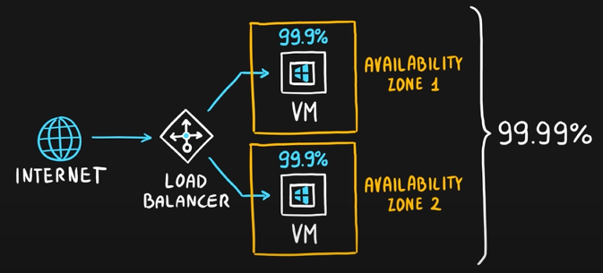

If the application becomes bigger, we might need to divide it into **many tiers.** Let’s divide into two tiers now. **Web tier** which handles web traffic. **Data tier** which handles data of the application. **Web tier** will have its own **load balancer** having a **public IP**. It will allow public **internet traffic** to come in. **Data tier** will have its own **load balancer** with **private IP.** This will allow only the **private connectivity** between the web tier and the data tier. This will be called **internal load balancer.**

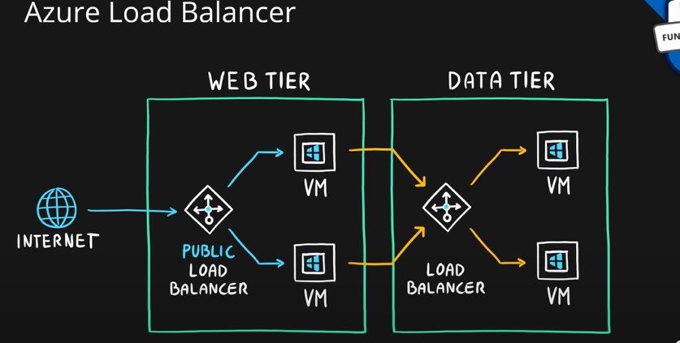

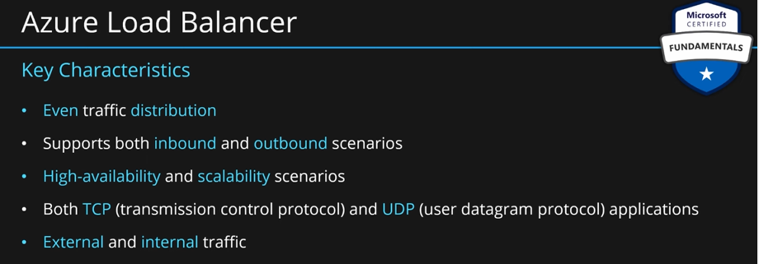

## Application Gateway.

Very similar to load balancer. If the traffic which we want to distribute among resources is HTTP web traffic, then we can use app gateway instead of a load balancer. Application gateway is designed specifically for distributing web traffic.

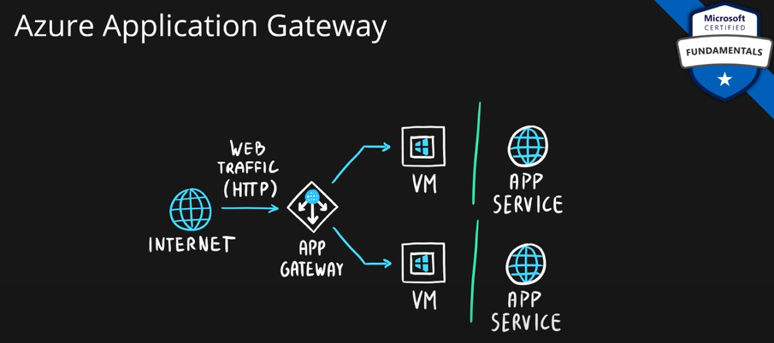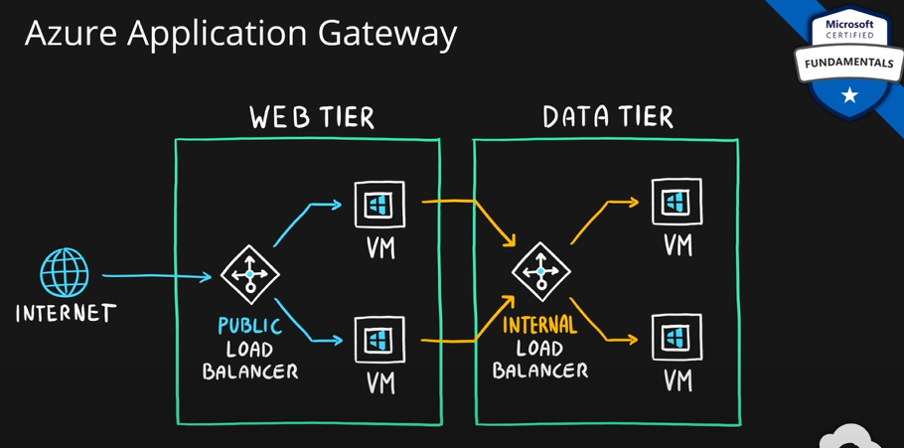

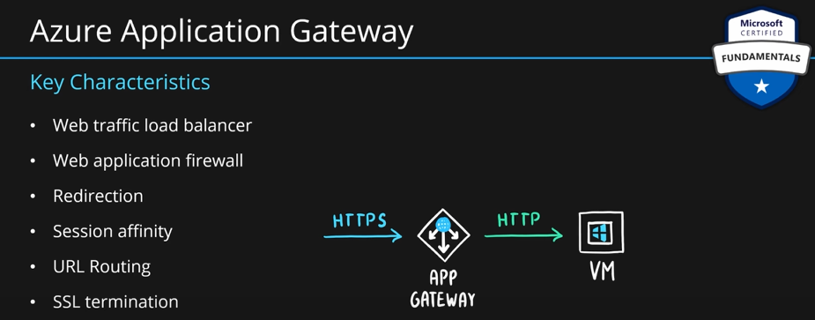

## Content Delivery Network (CDN).

It helps customers to build their applications. Let’s consider a web app as an example. If we are creating a web app, we have static content such as JS, stylesheets, static pages, images etc. Without CDNs, we will simply bundle this application and put it in app service. We then host this app service in one of the azure regions around the world. Let’s say we host it in west US. If users connect from other continents, then the delay is significant.

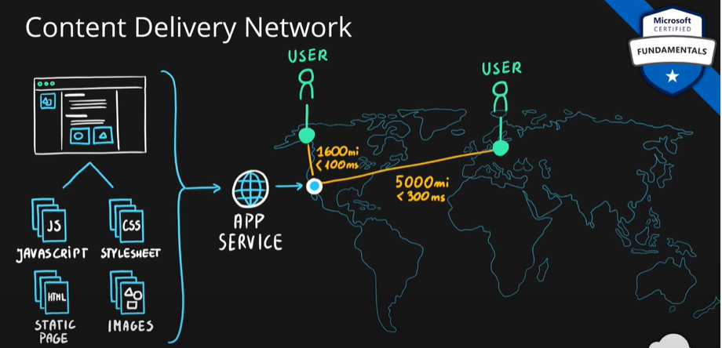

With CDNs, we will upload all the static content of our application into CDN. CDN service will then distribute this content all around the world into points of presence (POP). MS has many POPs all over the world. Currently azure has 192 POPs and 60 regions. So, more POPs than region, which means users might have a POP closer to them than the region. Users will now connect to the closet location.

This will:

* Reduce the latency.
* Reduce the workload required by the front-end services.
* Allows us to scale our application more.

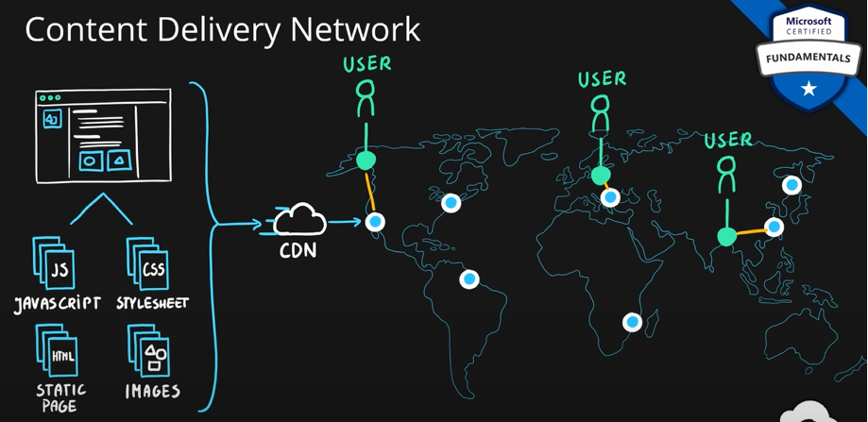

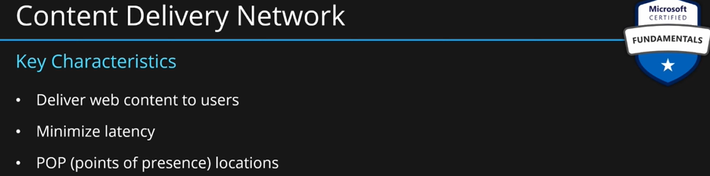

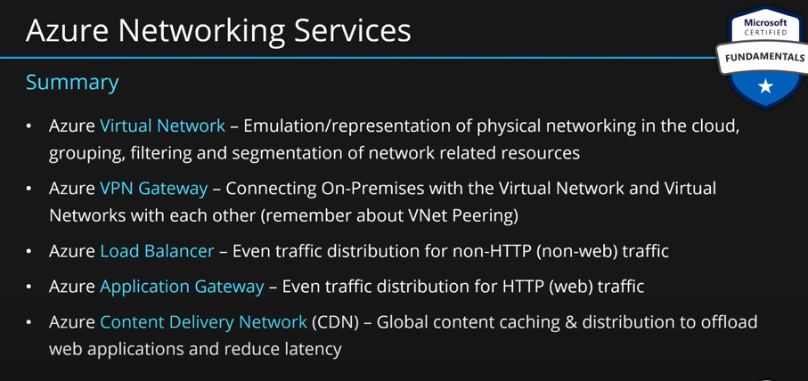

## Database Services.

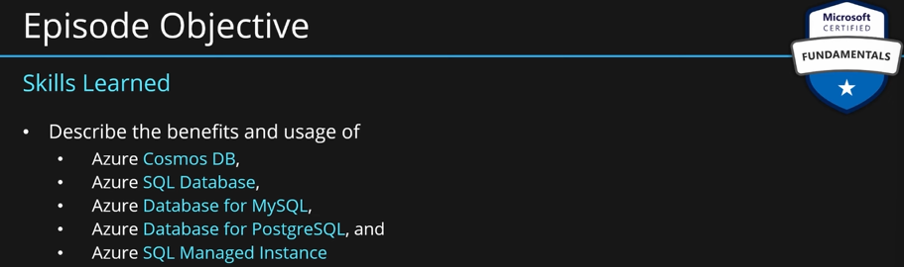

We will only talk about structured and semi-structured data in this section.

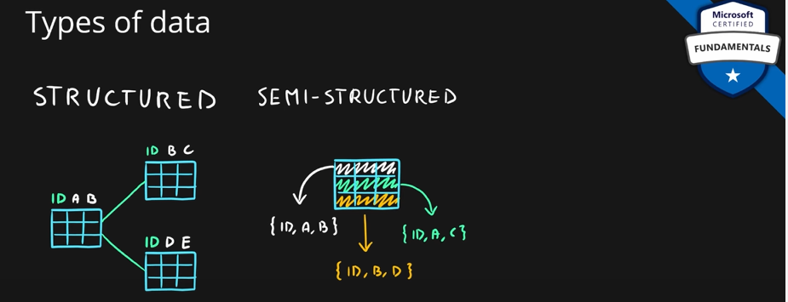.

### Azure Cosmos DB.

This service is used to store **semi**-**structured** **data**. Similar to azure **table** **storage**. Here, **tables** are called **collections**, **table** **storage** is called **cosmos** **DB**.

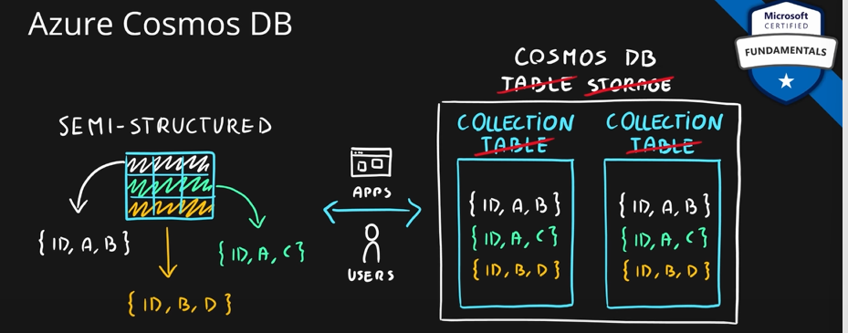

The main difference between table storage and cosmos DB is its ability to replicate geographically. Cosmos DB is available in many regions. Replicating across those regions is as simple as checking a checkbox. Whichever regions you choose, your data will be replicated to those regions automatically.

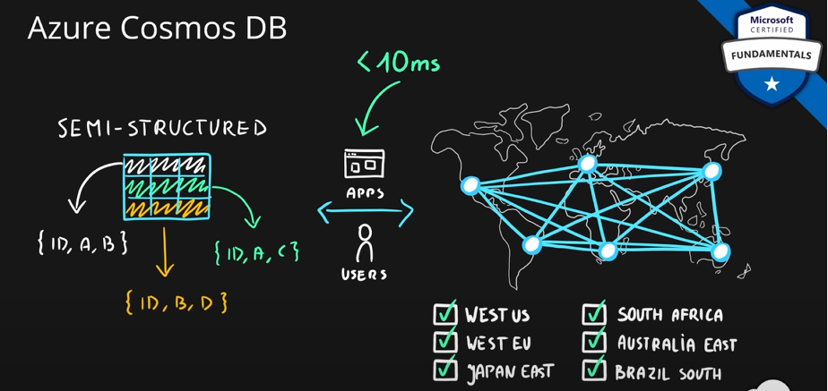

Another feature of cosmos DB is its ability to **read and write globally**. User can read data from the closed region where cosmos DB is present, on top of that, user can also write to the closed region. Due to its **geo-replication capabilities**, this data is **low latency database.**

This is the best choice if we are building a **real time application.**

This service also provides **multiple APIs.** It provides **core SQL API** which allows to query data effectively. You can use **MongoDB** or **Cassandra DBs** if you are working with them. You can also migrate **table storage to cosmos DB**. You can also use **Gremlin** which is a **graph database**. So, you can also store graph data.

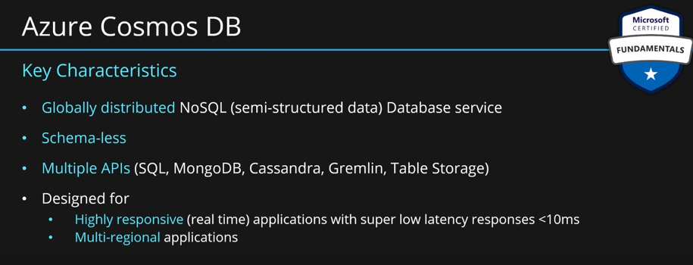

### Azure SQL Database.

For structured database. Relational DB service. 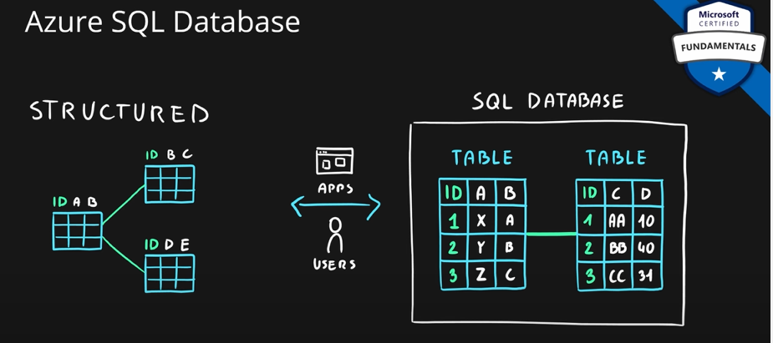

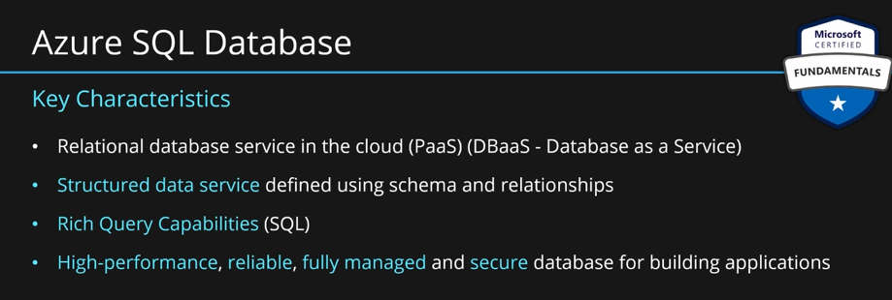

MS products for data are converted in Azure. See the mapping below:

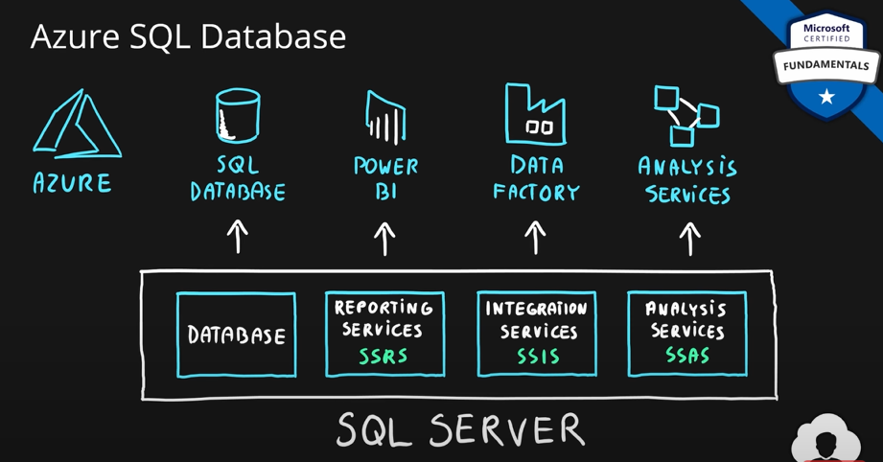

### Azure SQL.

It is a family of services with similar capabilities.

**SQL Database:** Based on the most recent stable version of SQL server. It does not provide full features because it is designed as a PaaS.

**Managed Instance:** If you need full capabilities of SQL server on-premises but in the cloud. It is a bit pricy. It gives you full capabilities. If some features are missing in SQL database, you can opt for **managed instance.**

**SQL Data Warehouse:** This is a version of SQL for massively parallel processing operations. For big data, data warehousing.

**SQL VM:** Running SQL server on a VM. It is IaaS option but very close to PaaS. You get all the cool features of azure SQL like backups, replications, security, monitoring and automated updates on OS.

If you don’t want SQL server or you want to migrate existing DB to cloud, then you can use one the below services:

**DB for MySQL, DB for PostgreSQL**

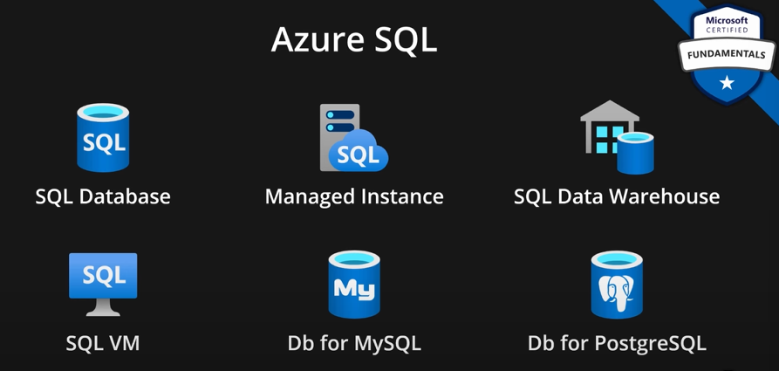

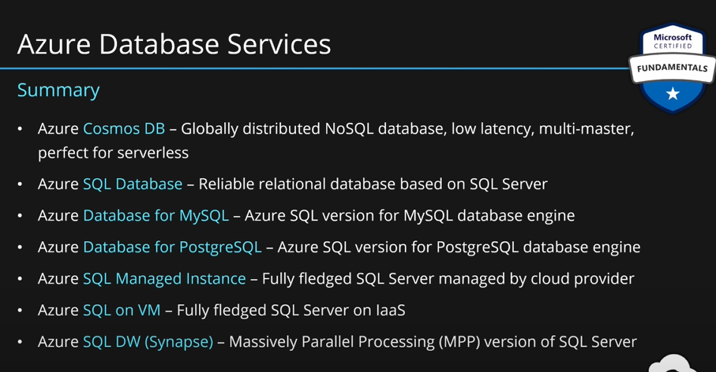

## Azure Marketplace.

Just like an **online shop**. You can search for services in azure marketplace. Marketplace has **templates** for services. A template can have a single or multiple services.

It has **products** created by **MS** or other **third-party venders**. You can also build your own templates and publish them on azure marketplace. Products in marketplace may be **IaaS, PaaS, SaaS.**

If there is any licensing needed, that will be charged through azure. You don’t need to externally buy and pay for licensing.

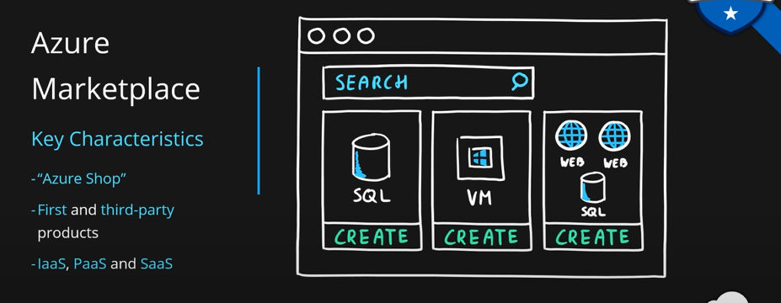

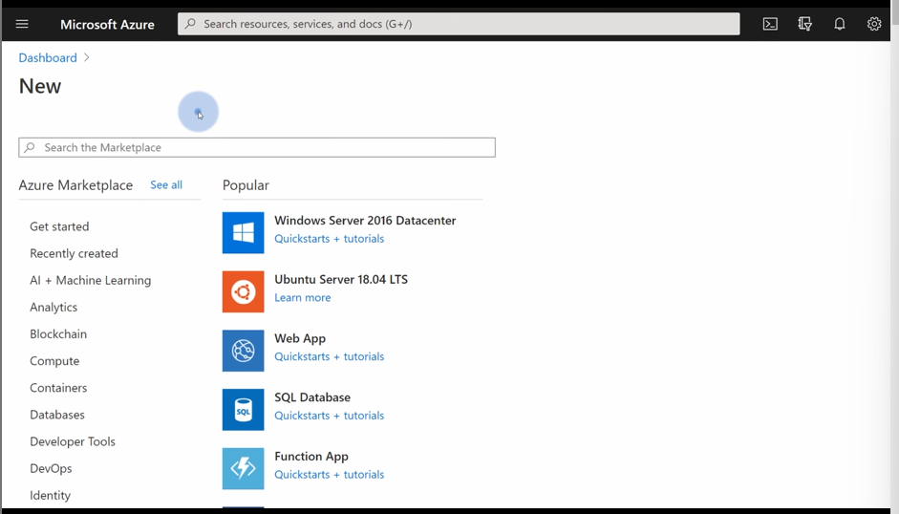

**Marketplace is a part of bigger thing. This is called Commercial Marketplace.**

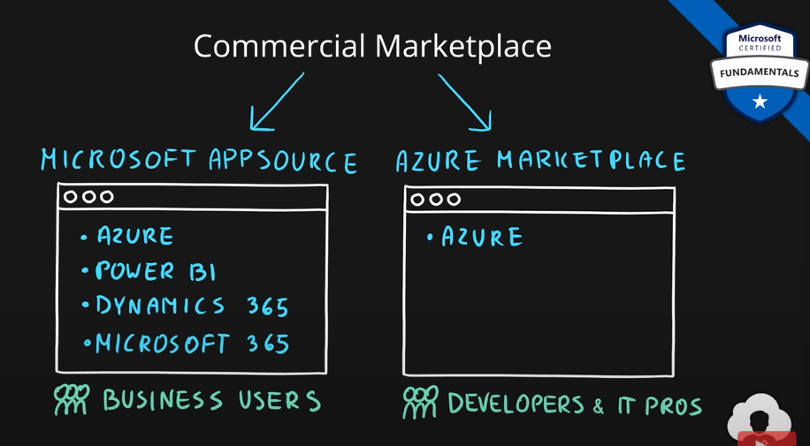

## Azure IoT (Internet of Things).

These are devices embedded in everyday object such as watches, homes, phones, cars etc. They send and receive data from the cloud. This data can be settings data or telemetry data.

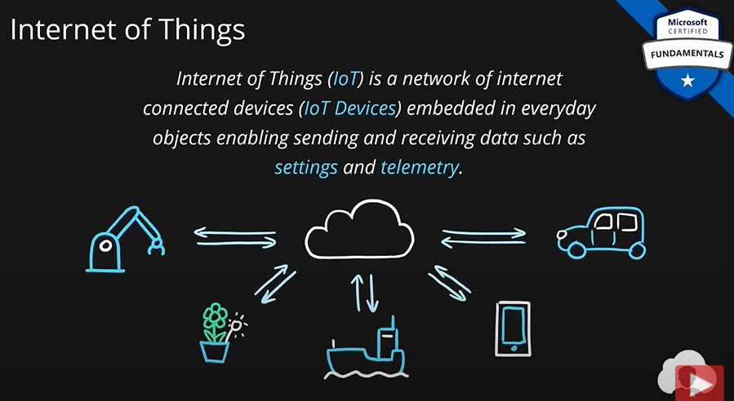

This is provided by **Azure IoT Hub.** This service allows bidirectional communication between the devices and cloud. It then uses this data and provides insights and monitoring and development of custom solutions based on this data.

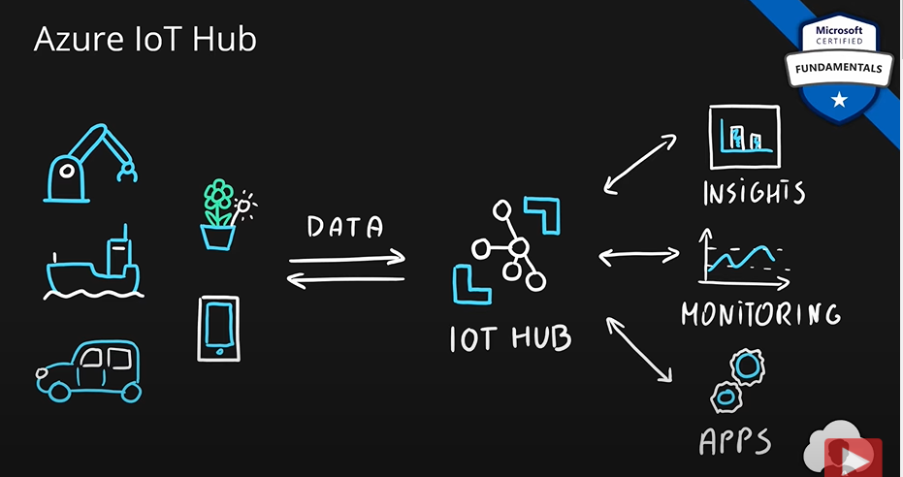

**Key Points:**

* It is a managed service for bidirectional communication between the cloud and IoT devices.
* It is **PaaS** for IoT development.

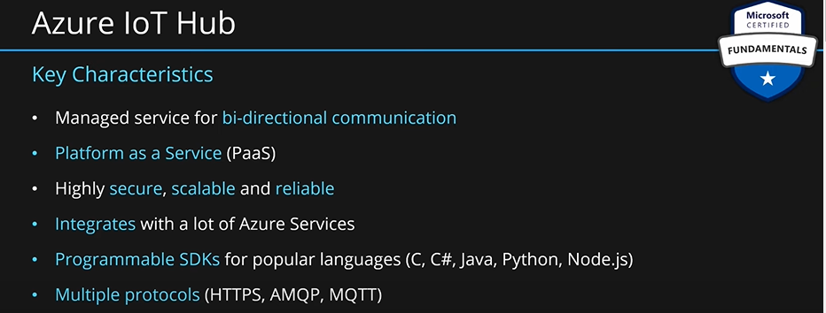

We can create custom IoT solutions using this service. We will get data from IoT devices on azure. Based on this data we can develop solutions for ourselves. It allows to develop in any language such as C, C#, Java etc.

Azure provide **Raspberry PI Azure IoT Simulator.** It is a small web page created by MS. Here we can simulate IoT devices and play around. We don’t need to buy any physical IoT devices.

**Azure IoT Central:** It allows IoT devices to connect to the cloud. But IoT Central service also provides templates to make apps. It is an application delivery platform for device management and centralization purposes. It is best for those organizations that want to take advantage of IoT but don’t want to build applications from scratch.

**Key points:**

* It provides apps; hence, it is **IaaS**.
* Provides industry specific app templates to get out of the box solutions for your IoT and manage them on scale on the cloud.
* This service is built on top of **IoT Hub.**

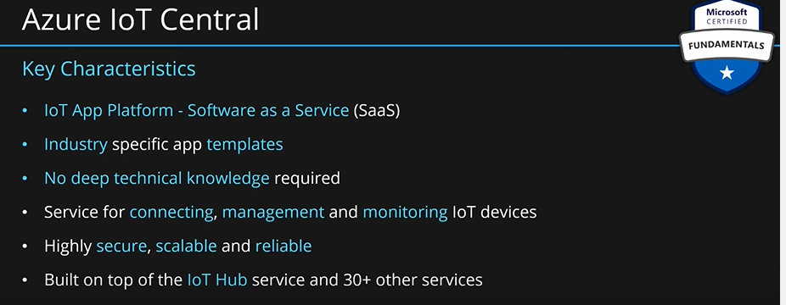

## Azure Sphere.

It is a set of components that allow you to build secure IoT apps. Let’s say we have washing machines, and we are building applications that will run on those washing machines. Azure sphere provides **Micro-Controller Unit** (**MCU**). These sphere MCUs are simple chips build based on MS standards and specifications. Azure sphere allows provides an **OS**. MS manages this OS and makes sure this OS has latest updates and security patches. We can build our application on top of this OS. The third thing azure sphere provides is **Azure Sphere Security Service.** This service is used to provide secure communication between your device and the IoT device. MS can provide updates to the OS using this service.

This service provides hardware, OS and communication channel for IoT solutions.

All of this is done to build secure end to end IoT solutions.

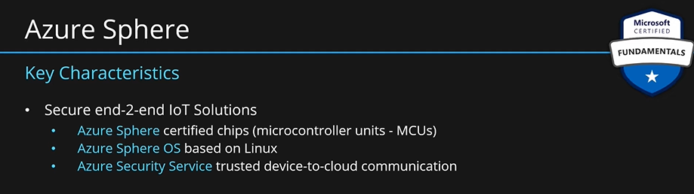

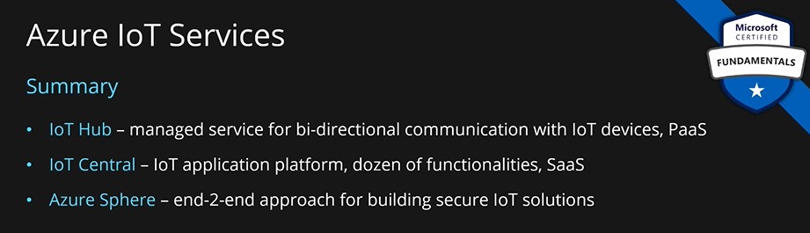

## Big Data Services.

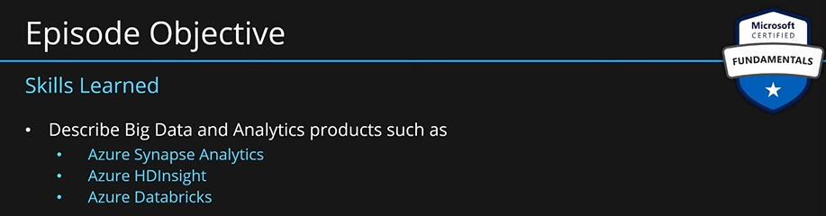

What is **big data:**

**Terminology:**

**Velocity:** How fast is our data is arriving? How often do we have to process that data? Are we processing that data in batches or in real time?

**Volume:** How big is the data? MBs, GBs, TBs, PBs of data?

**Variety:** What type of data? Tables, databases, photos/videos?

Based on above three, we decide if the data is big data or not.

As soon as we go far in one of the vectors, traditional software will not be able to handle that kind of information.

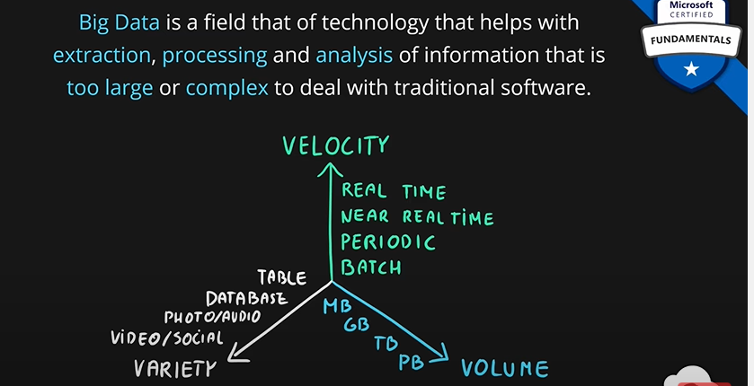

Azure provides many services to work with big data.

### Azure Synapse Analytics.

How a normal process looks like?

1. Data engineers will identify where their data will come from. It can be a web service, database or flat files. Then the typical development process starts.
2. Developers will first ingest this data into the cloud.
3. Transform this data.
4. Store the transformed data.
5. Expose the stored data to other services like reporting tools. So, the business users can take insight from this data and make good business decisions.

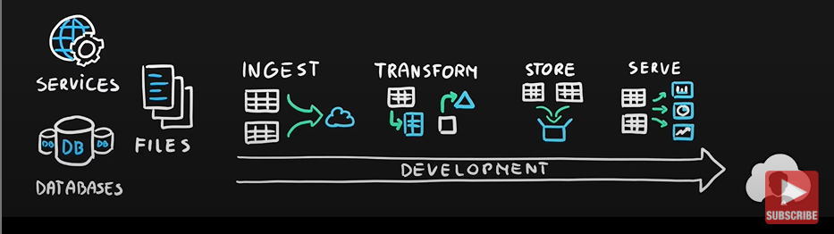

**Azure Synapse Analytics** helps with all of these steps. It provides a synapse called **pipeline.** This tool helps developers to ingest and transform their data using visual workflows. It comes embedded **Apache Spark**, a leading technology for big data analytics and transformation. In addition to this, there is also **synapse SQL,** a massively parallel processing database clusters based on a popular **SQL Server.** This helps transformation using typical SQL queries, storing the data and also serving it to reporting clients.

All of this comes combined inside **synapse studio,** which is a unified experience to manage all of those tools and features and perform all of your data transformation in a single place.

All of this is nicely integrated with another azure service called **azure data lake.** So, ingestion, transformation and storing of data can also be done on data lake.

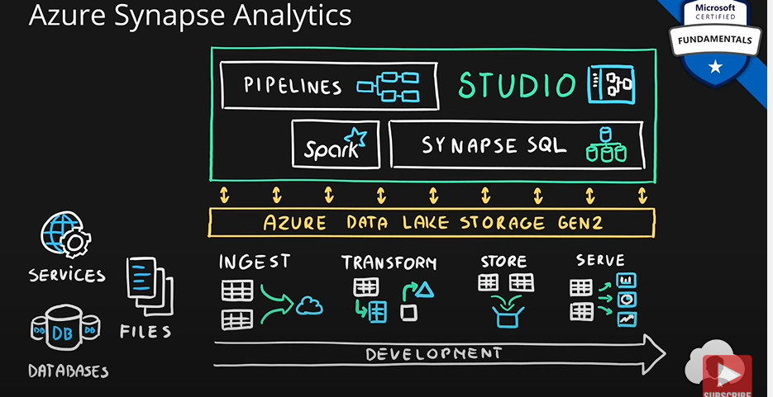

**Key Points:**

* It is a big data analytics platform (PaaS). It allows users, data engineers, data scientists to perform data analysis and data transformation over very large datasets.

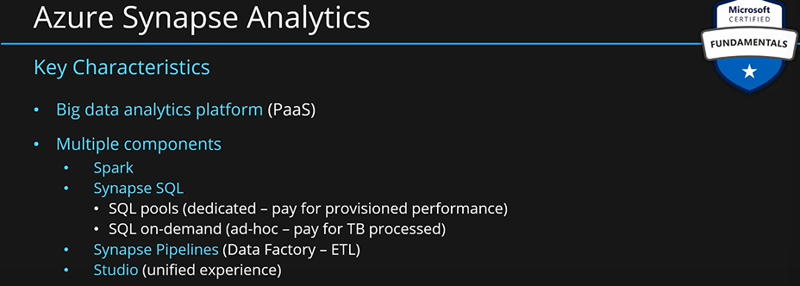

### Azure HDInsight.

This service can help with every step of the development process by providing **Big Data Clusters.** Many clusters are available such as **Spark, Kafka, HBase, Hive, Apache Storm** etc. The idea of this service is to provide you with open-source big data technologies from the market, provide you with clusters. MS will manage these clusters. You grab whatever technology you need to perform specific tasks; you need to do.

All of these tools serve different purposes. You can use a combination of them as per your need.

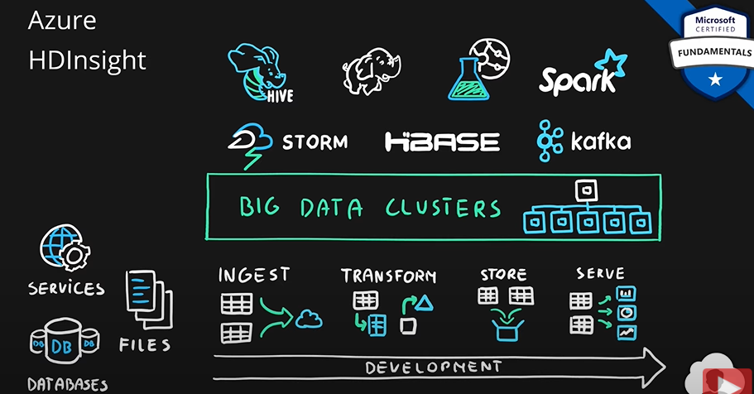

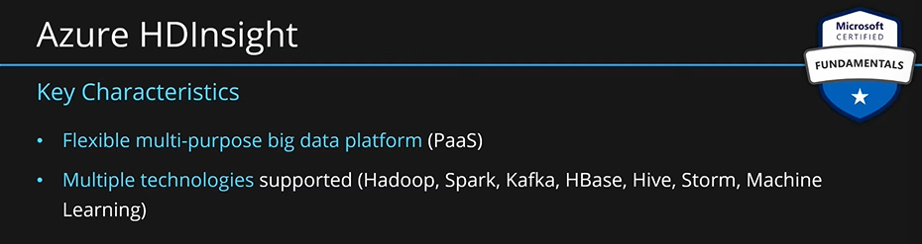

### Azure Databricks.

Very similar to HDInsight but the clusters that we create are based on **Apache Spark** and Apache Spark alone. Main purpose of this service is to help you with data transformation at large scale. Apache spark is one of the leaders when it comes to performance and transformation of big data.

It is also a collaboration platform for data engineers and data analysts. So, they have a single place to manage their cluster and collaborate on their data solutions.

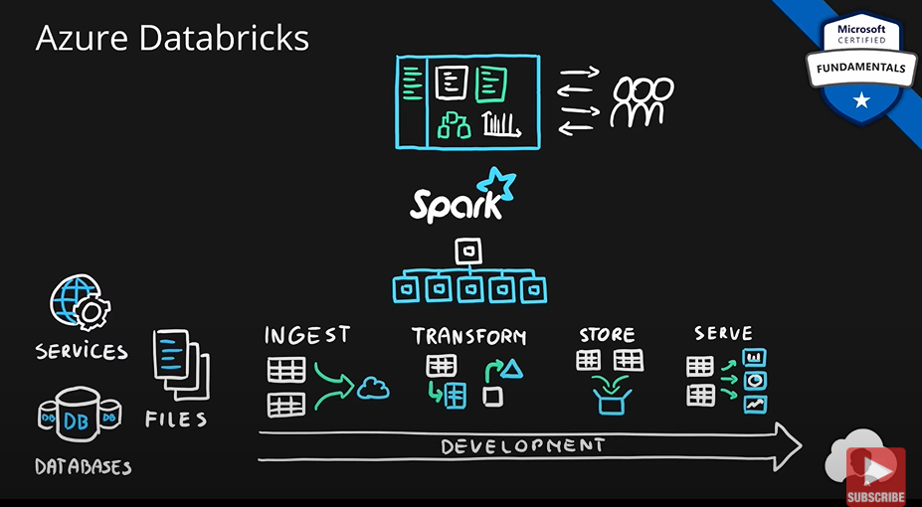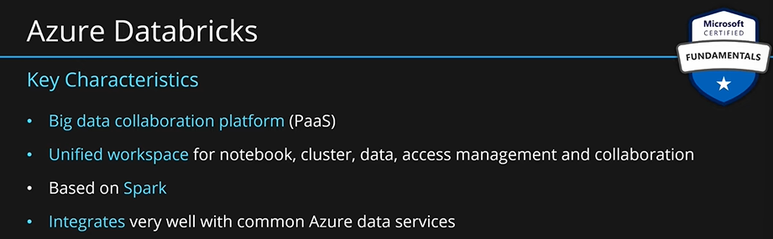

**Summary:**

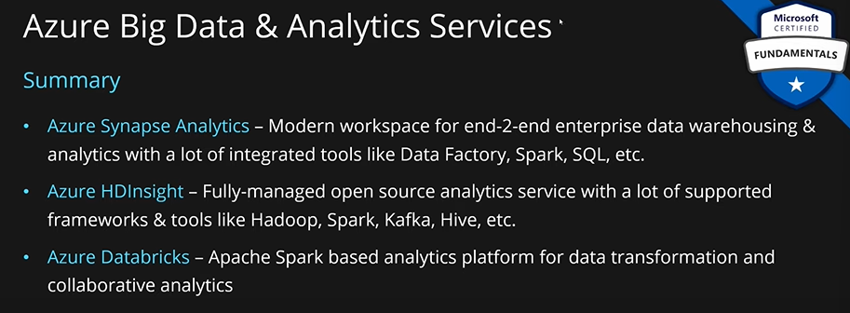

## Artificial Intelligence Services.

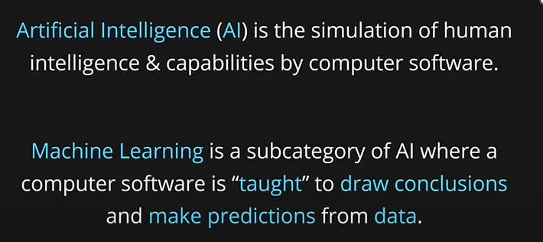

Using AI, we want to make predictions. The process of teaching a software to do that is called building a model. The key service provided by Azure to do that is called **Azure Machine Learning.**

**Azure Machine Learning:** We first train the model on data. We then package that model. We then validate that model. If we are happy with the results after the validation, then we deploy that model as a web service. After deployment, we monitor the service and retrain the model based on new data and make the model even better.

**Azure machine learning** helps us with all of these steps. This service provides many tools. Tools such as **notebooks written in python or R.** It also provides a **visual designer** which allows us to build machine learning models using simple drag and drop experience in our browsers. Additionally, we have a platform where we can train, package, validate and deploy these models.

Another useful feature this service provides is, **auto ML.** This feature allows us to drop random algorithms at our data and see which one scores the best and deploy that as our web service.

There is another feature called **pipeline.** This allows us to build this entire process end to end whether we are using notebooks, designer or auto tools. This is complete end to end solution for building machine learning models.

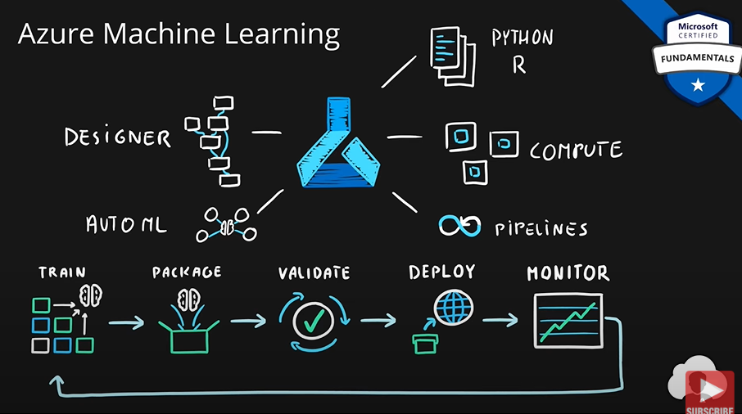

**Machine Learning Studio:**

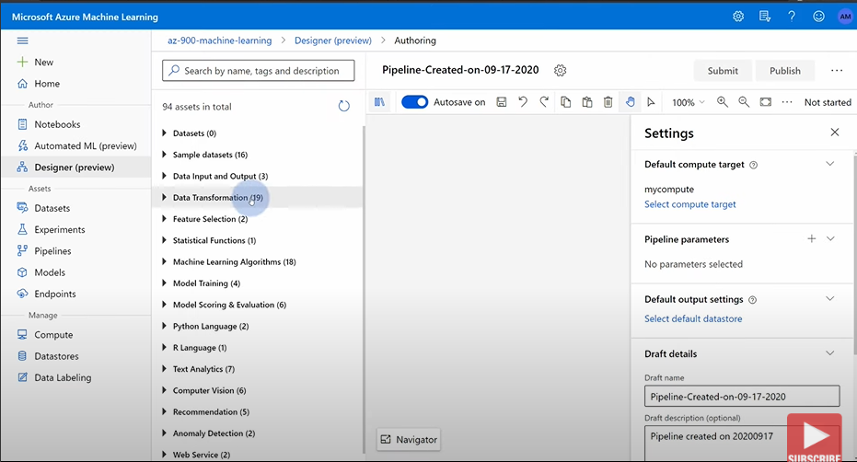

**Summary:**

**Machine Learning Workspace** ties everything together. It is the top-level resource of this service. It will show, all the compute resources, all the permissions, runs, pipelines, experiments and everything else related to this service.

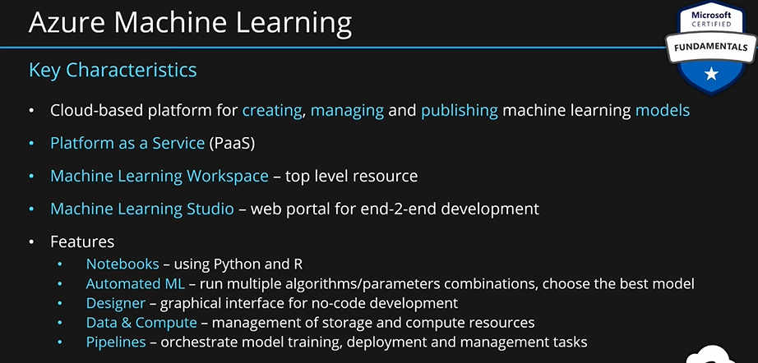

## Serverless Computing.

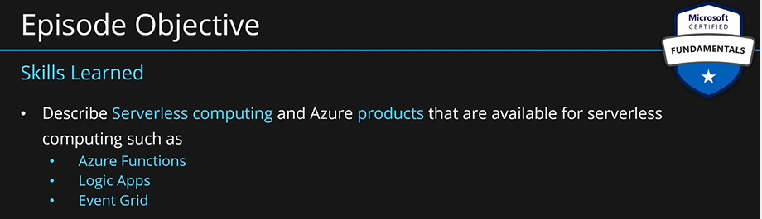

We will simply deploy our app or using out of the box products available on azure while making MS take care of the infrastructure. MS will scale up and down to match the demand.

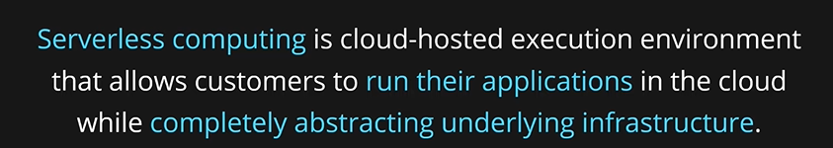

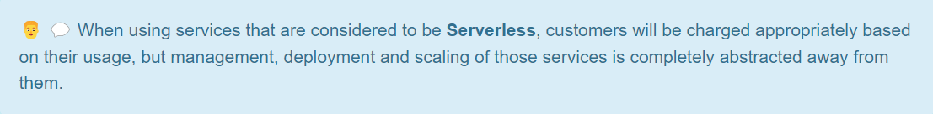

### Azure Functions.

They are a serverless compute resource. We develop small pieces of code and deploy/host them as a web service. Process is: Develop small pieces of code 🡪 package this code 🡪 deploy this code on function app 🡪 function app deploys this package on many nodes 🡪 external services can now use this function.

Scaling up and down is done automatically.

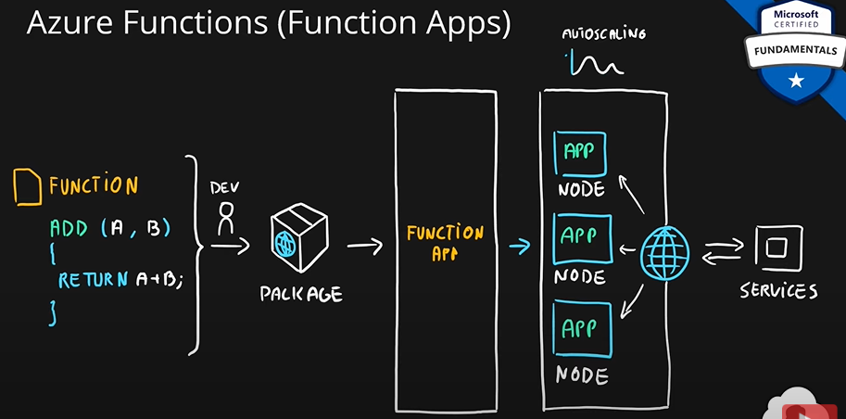

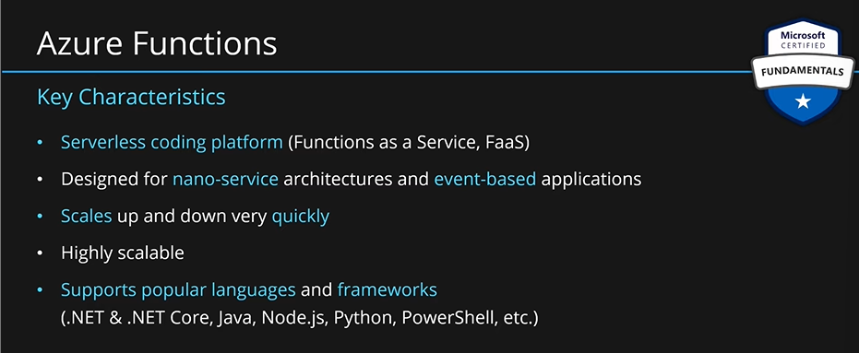

### Azure Logic Apps.

This service allows you to build workflows using visual designer. These workflows can represent both business scenarios and cross application integration. You can have if-else conditions, loops, or even parallel runs in the workflows.

You can trigger your workflows from a web request or email or office 365 events or even based on things that might happen in azure account or events from other technologies such as salesforce or other SaaS apps. There are more than 200+ connectors.

You can use these connectors in your workflow as well. Eg. You can send a mail from the workflow or a web request or save files to blob or write data to SQL DB.

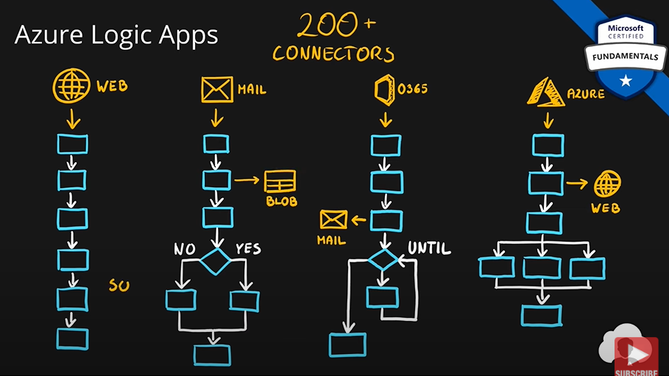

For example, you can create a logic app to send you a mail every time a file is uploaded to a specific folder in azure storage account. You can think of many scenarios, where you can use this service.

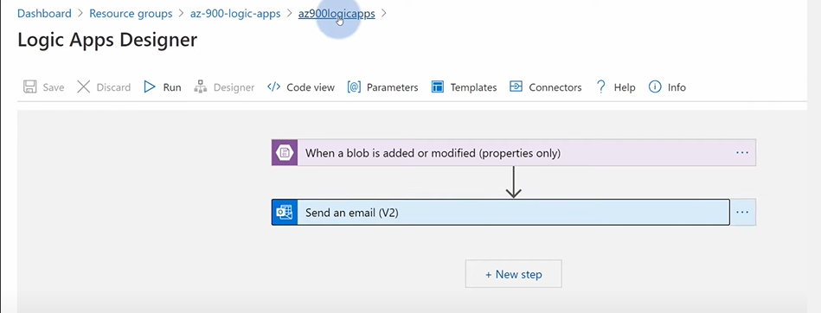

Here we just defined the flow, all the other things such as scaling and everything is taken care of by MS.

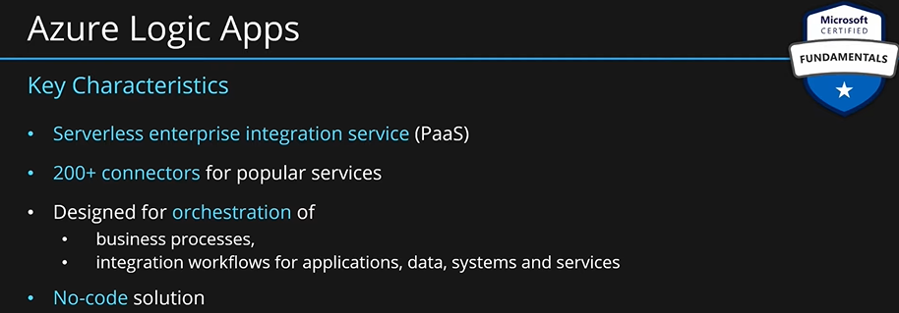

### Event Grid.

This is a service for routing messages. Many services will send events to the event hub. These services can be azure blob storage, azure subscriptions with some subscription events, event hubs or a custom web application. These messages are called **topics**.

Once the topics are received by the event grid, event grid will have services that have subscribed to those events/messages. These are called **subscribers**. These can be azure functions, logic apps, web hooks, queue storage etc. The job of event grid is to deliver/route these topics/messages to the subscribers.

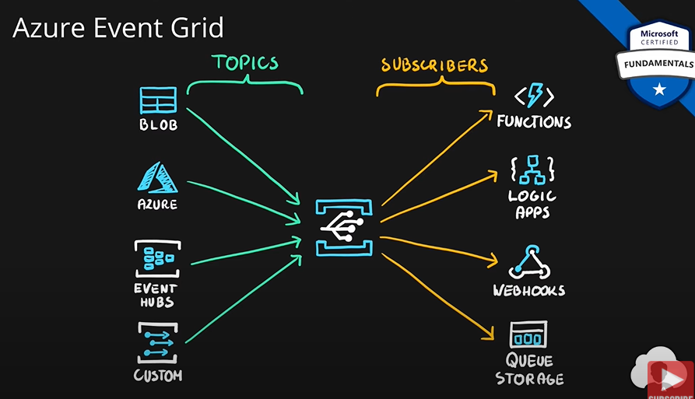

We can just subscribe to a topic without having to worry about the underlying infrastructure. All these are managed by MS. This is why this service is also called **fully managed service.**

It supports a lot of built in events from azure services. Eg if your virtual machine goes down, an event will be sent to the event grid which you can react to using your application. You can react to anything that happens in azure using event grid. Creating a VM, scaling a VM, VM failing, a resource is provisioned etc. You can create applications which will react to the events happening in your azure account.

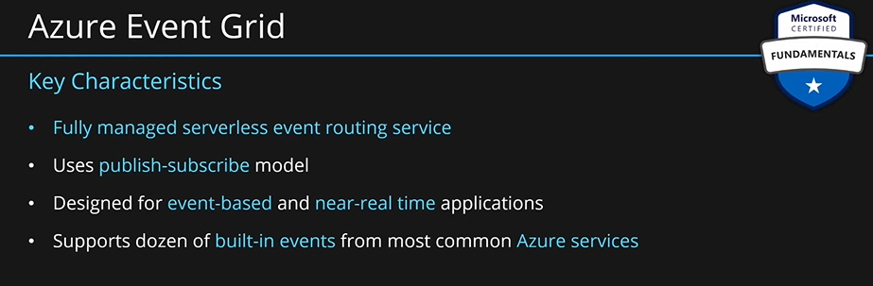

**Summary:**

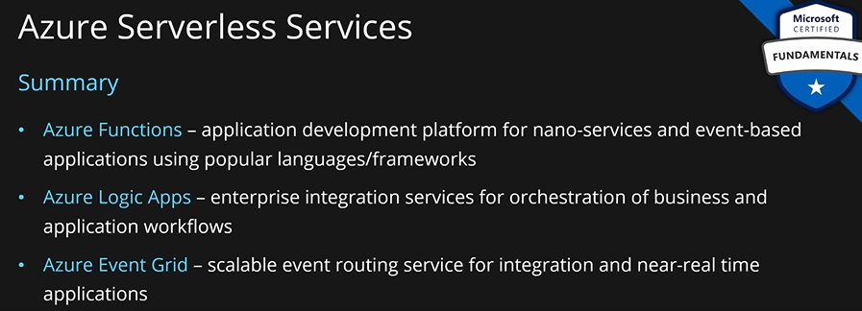

## Azure DevOps and Azure DevTest Labs.

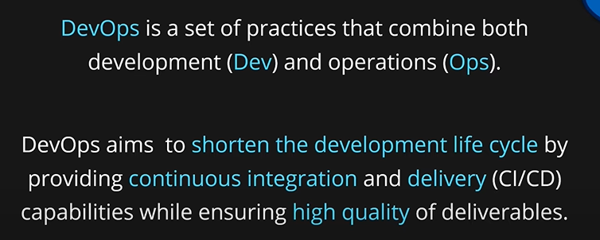

So, the idea is to deliver faster and ensure that the quality is highest.

**Azure DevOps:** Key Features:

**Boards:** This feature allows users to track their work and progress. Create user stories, put and change the status of user stories, track the progress among team members. This also allows to manage the deliverables, work status etc. for the user stories in a single place.

**Repos:** Allows users to manage code repositories and code versioning for your project.

**Pipelines:** Allows users to create automated builds and automated deployment processes for their code and applications across multiple environments.

**Artifacts:** Allows users to create hosts and share packages with your team. You can also add the artifacts that your have created to your CI/CD pipelines with a single click etc.

**Test Plans:** Allows to track our testing progress with manual and exploratory testing tools.

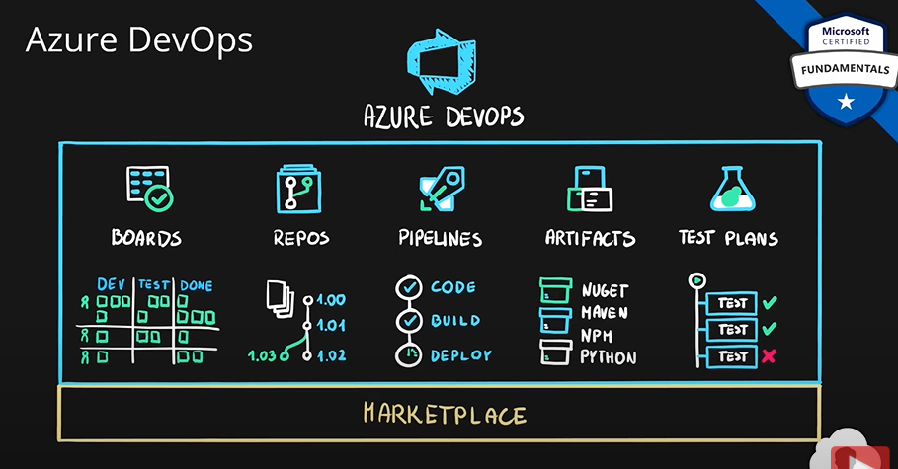

**All of these features are combined together in azure DevOps.** On top of this, there is also marketplace available with many other additions to azure DevOps. With marketplace, you can extend the basic functionality and customize everything to your needs.

In summary, Azure DevOps is a collection of services that help customers build solutions with the use of DevOps practices. They do that by providing services such as boards, repos, pipelines, artifacts, test plans etc.

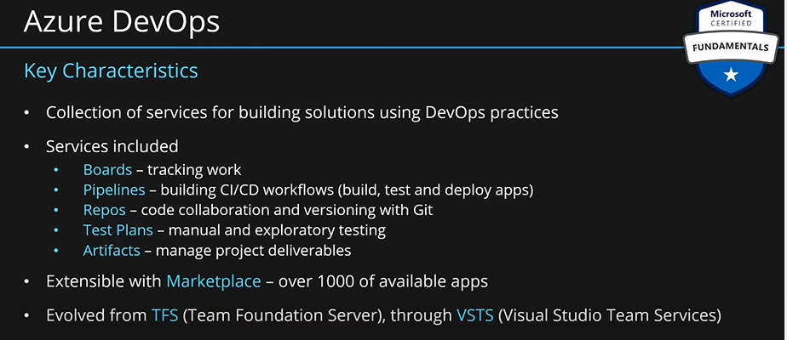

**Azure DevTest Labs:** It provides a workspace for the users within azure. Users who can be developers or testers can build their own VM. For creating VM, users can choose any image. User can then install some artifacts such as visual studio, 7zip, git and docker etc. User can create multiple VMs and choose any configs for these VMs ie OS and artifacts. The aim of this service is to allow users to create VMs quickly to develop and test things quickly and destroy these VMs as soon as they are not needed. All of this is provided within a workspace.

In order to control the cost and control your organizational resources, admins can come to azure DevTest labs and apply a set of policies. These policies can tell which OS images can be used, VM sizes, quotas for each user for provisioning VMs. This service provides great flexibility for developers and testers.

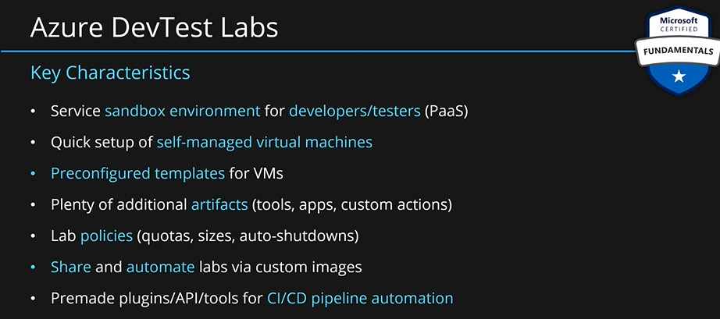

**Summary:**

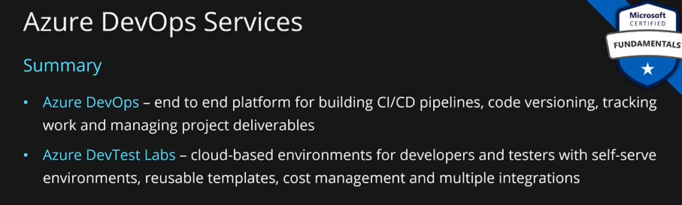

## Describe securing network connectivity in Azure:

Securing virtual networks using **network security group (NSG).**

### Network Security Group (NSG).

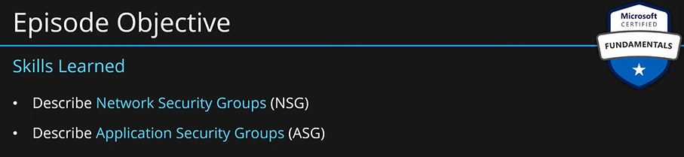

Let’s say we have four servers, two handle our web application traffic, one handles the business logic, and one server hosts the DB. Depending on our infrastructure, we will divide them into subnets. One subnet for all the web traffic and microservices (business logic) and one subnet for the server that hosts the DB. Since they are subnets, they will reside inside a virtual network.

If we create such an architecture, then internet traffic can go to both the subnets and subnets can route traffic to each other as well. Main point is that Internet traffic can go to all the servers.

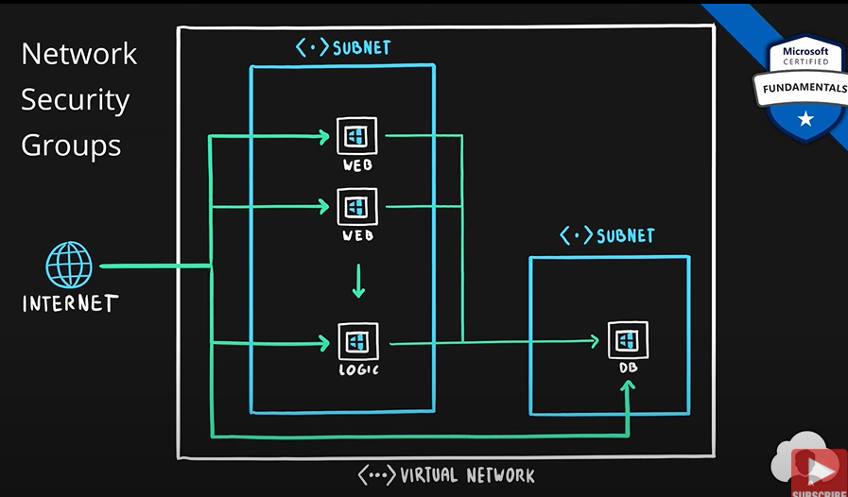

In this scenario, we don’t want our internet traffic to reach our database. Also, not all the services should be able to talk to each other. This is where we use **network security groups (NSG).** We out NSG on our first subnet and make sure internet can reach these servers. And by creating a NSG on the second subnet, we can block the traffic coming from the internet to this server but also, we allow other services in the first subnet to reach the second subnet.

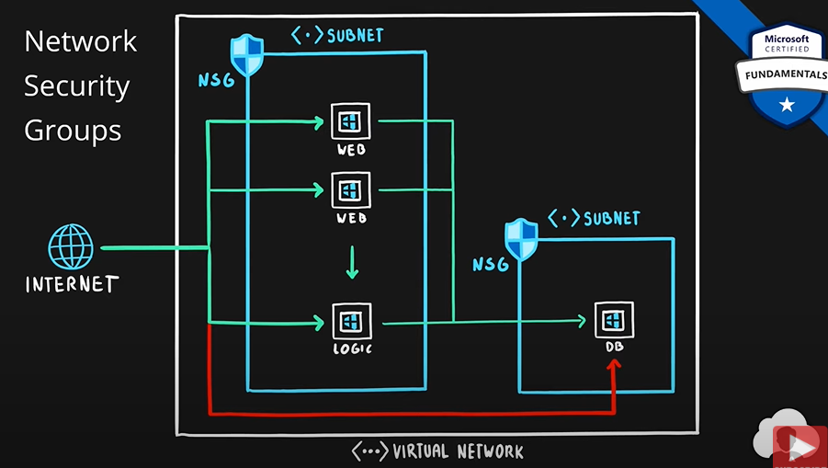

We can set inbound and outbound security rules to subnets or even single VMs:

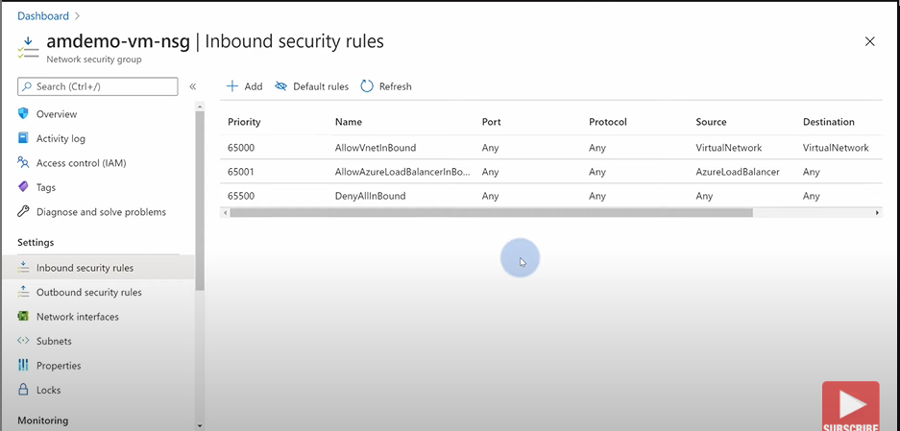

Here we can choose inbound and outbound rules.

**Key Points:**

* NSG is used to set up traffic rules/filters both IB and OB for azure resources located in azure virtual networks.
* You set up rules for IB and OB.

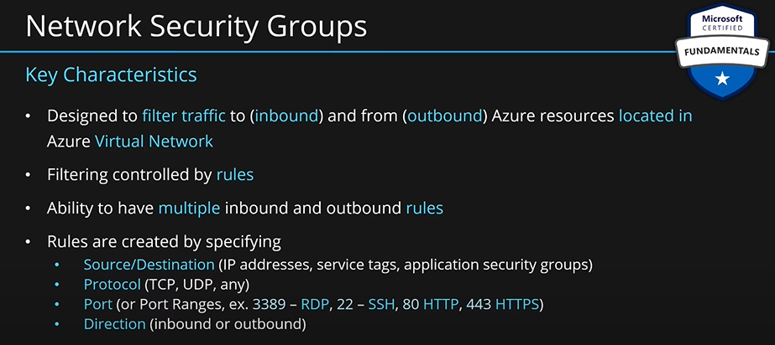

### Application Security Groups (ASG).

In our previous example, if we want to only allow traffic to our business logic server from the web servers and we want to block traffic to our logic server from the internet. Also, block internet traffic from going to the DB. Only allowing the business logic server to connect to the DB. Also, block the traffic from web servers to the DB server directly.

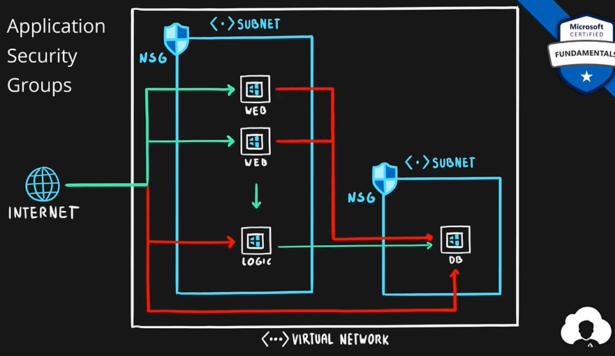

Flow Should be:

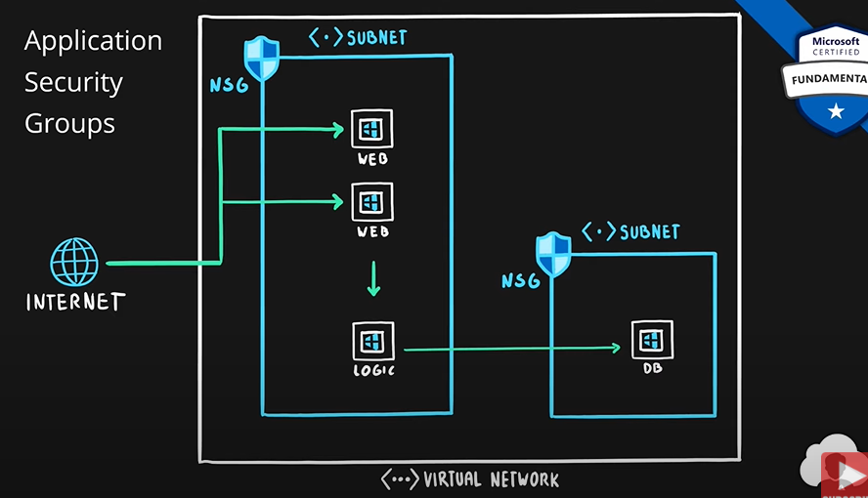

To achieve this using NSG, we will need to use static IP of all these servers in each rule. To requires a lot of work. We can solve this using ASG. We group our server by their business purpose. Then we will use those ASPs instead of the static IPs in NSG.

Without ASG:

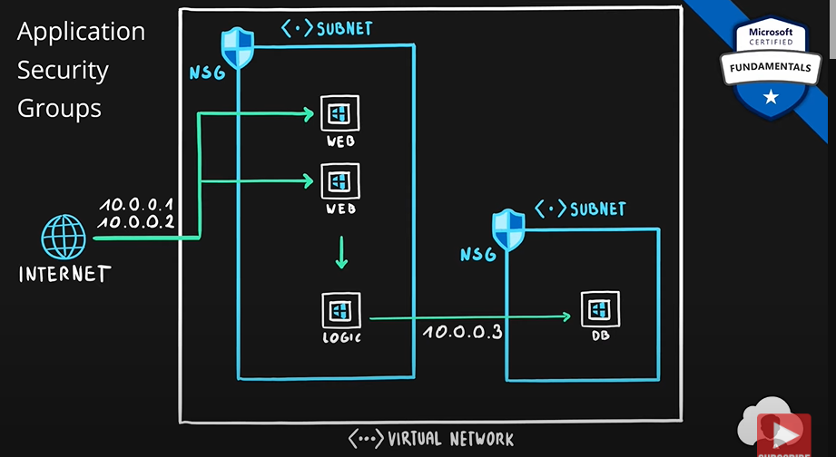

With ASG:

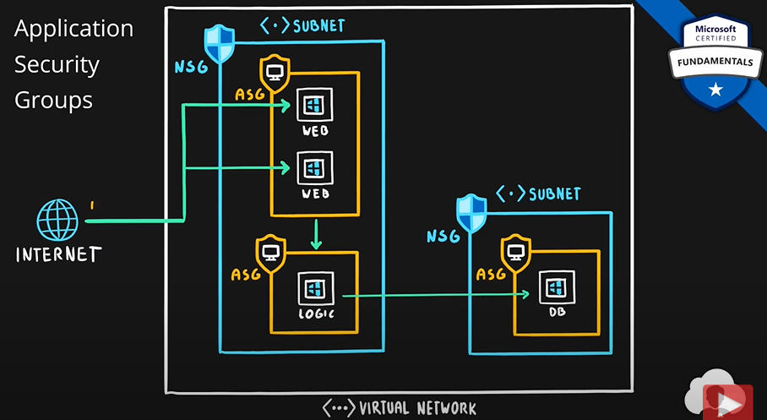

**Key Points:**

They help in setting up the NSGs.

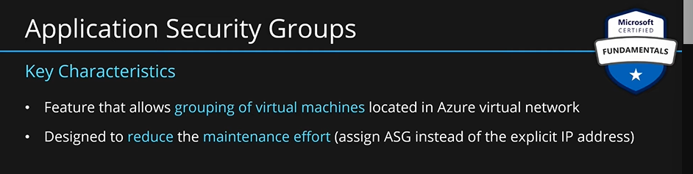

**Summary:**

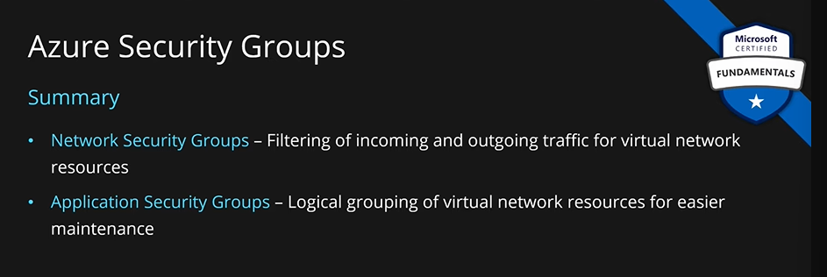

### User Defined Routes (UDR).

How to route our traffic inside a azure virtual network?

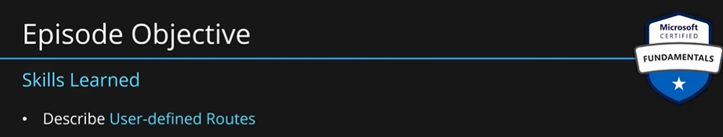

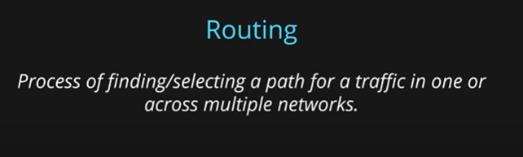

In azure, routing is set up by default. Let’s say you have two servers; one is a web server; and the other is an API server. Both are located in the same azure network but are in different subnets. If you want to connect to the API server from the web server, there will be route set up for that already. Also, if you want to connect to the internet from the web server, you have a route set up for that as well. Azure creates an **internal routing table** by default and adds all the default routes in that. With this, machines when provisioned can already connect to the internet and to each other.

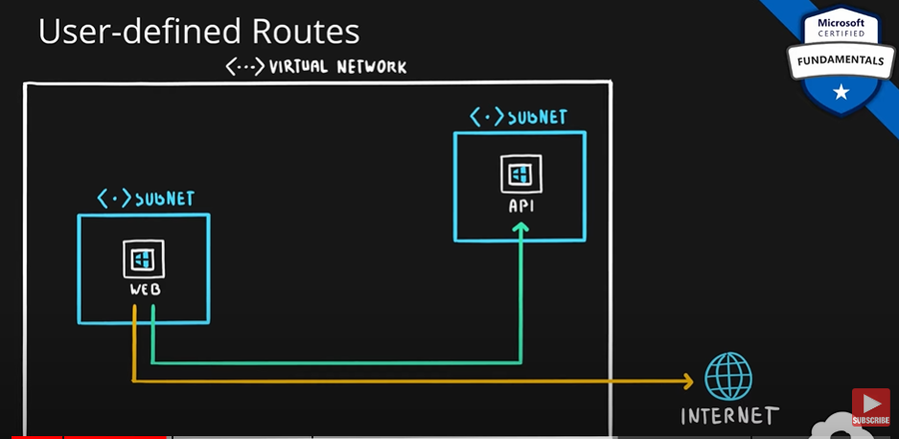

We can change this behavior by using the UDRs.

Let’s say we have a server called NVA (Network Virtual Appliance). This is an optimized machine to do specific task. Here, we are using it for a firewall. With a firewall, we can inspect all the incoming traffic before it reaches our internal servers. Here we create a route table which will override default routes in azure. We create our own routes in the routing table. We can affect how web server connects to the API server. The traffic will go through the NVA. At NVA, we will decide whether we want to continue or block it. By adding one more route we can affect the traffic going to the internet.

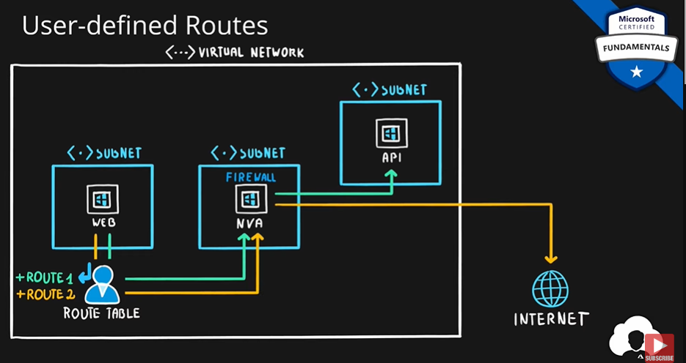

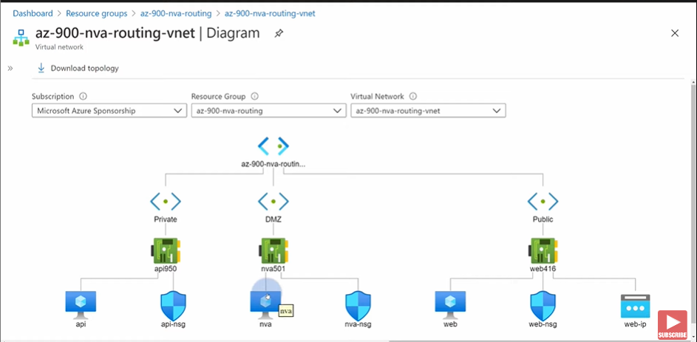

So, the network traffic will go through the NVA, and it will done by using a route table.

**Summary:**

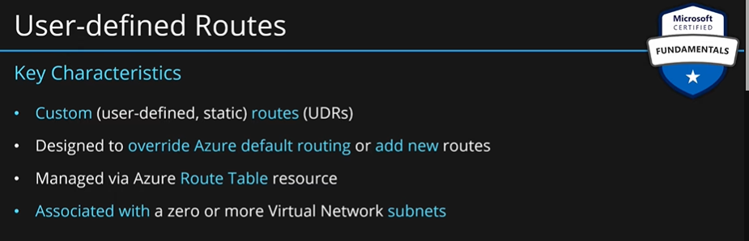

### Azure Firewall.

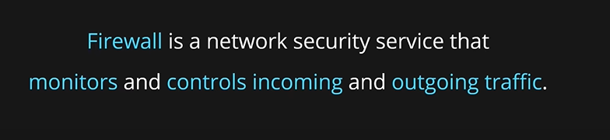

**Firewalls** can be simple which just filter the traffic based on IP and protocol just like **NSGs**.

They can be more advance filtering traffic based on FQDN (domain name of the services) or can inspect the body of the request, to prevent unwanted traffic.

**Azure firewall** is a managed service which allows us to focus on the network configurations rather than management of the infrastructure. It allows does centralization of our network configuration across multiple subnets and virtual networks. Then we can make sure with our rules which traffic should go through and which should be blocked.

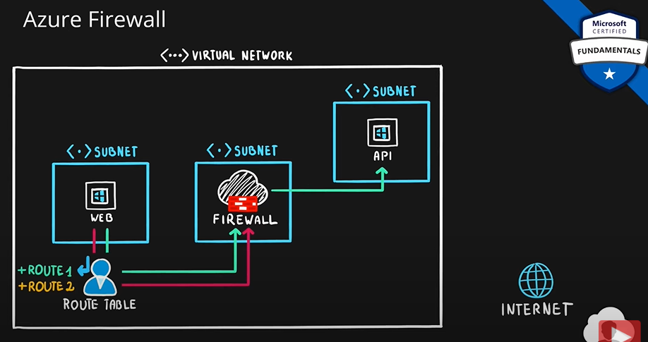

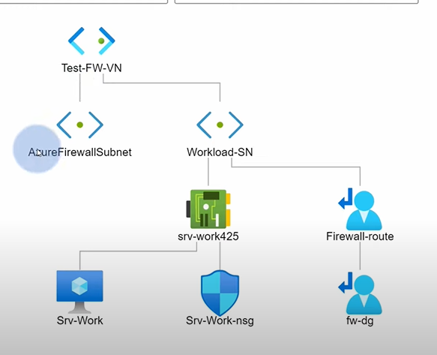

In the firewall, you can specify rules.

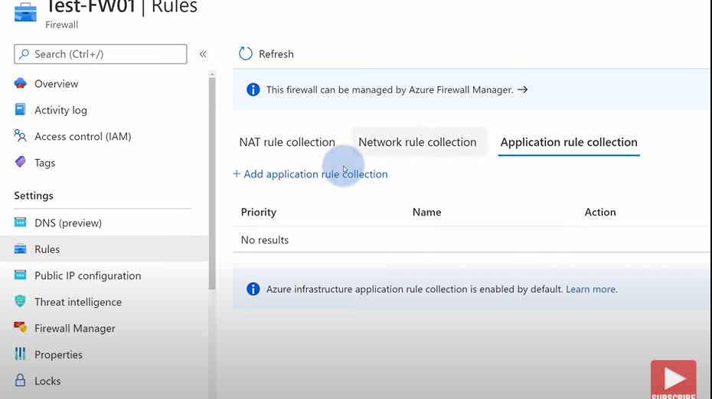

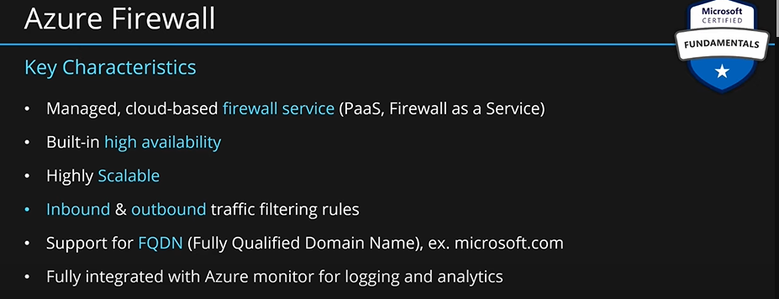

**When azure firewall is provisioned, by default rule is set which blocks all the traffic. In order to allow traffic, you have to manually set a rule to allow it.**

**Firewall allows FQDN, which means you can allow outgoing traffic only to certain websites. This cannot be done through NSGs.**

### Azure DDoS Attack.

**DoS: Denial Of Service.** Someone attacks your server that is exposed to public internet with an intent to disrupt that service from working properly. This may cause temporary or permanent disruption of your service. Users will not be able to use your service. Basically, any attack where the goal is to stop your service from working will be called a DoS attack.

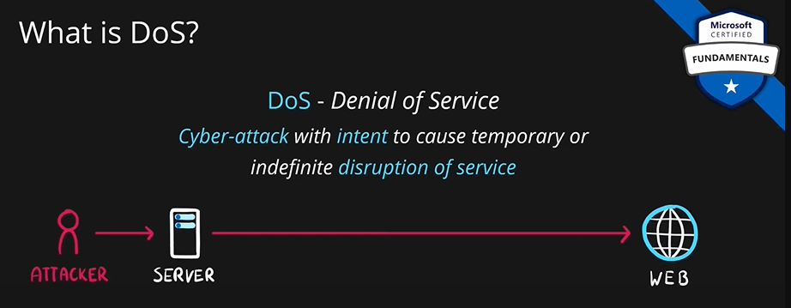

To avoid this you can simply block the IP from where the attack is originating. For this reason, most attackers will attack your server from many different servers. This kind of attack is called a **Distributed Denial of Service** **(DDoS) attack.** Preventing such attacks are tricky. You have to identify the attacker IPs and block them; at the same time you must allow the genuine requests for your services.

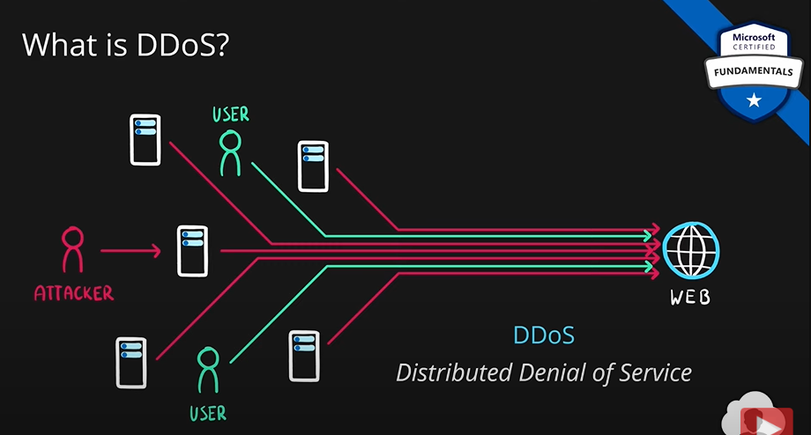

If this scenario happens in azure meaning if the web server was hosted on one of the azure services, then in front of the azure service, there would be **DDoS Protection,** which would filter that malicious traffic out and keep genuine traffic coming. Basic plan of Azure DDoS Protection comes with all the azure services by default. You don’t have to spend extra for the basic plan.

This service also comes with a standard plan. This is a paid plan. This can help you with more sophisticated DDoS attacks.

You can find DDoS protection plan in azure marketplace. When you take the plan, you have to choose all the virtual networks which you want to protect from DDoS attacks.

One advantage of this service is that if the attacker tries to attack from many servers, your services might scale up automatically to accommodate this traffic. This will increase the cost of the service. DDoS protection service will make sure this kind of scaling does not happen.

Another thing the standard tier of DDoS protection service provides is that it uses machine learning to analyze traffic patterns.

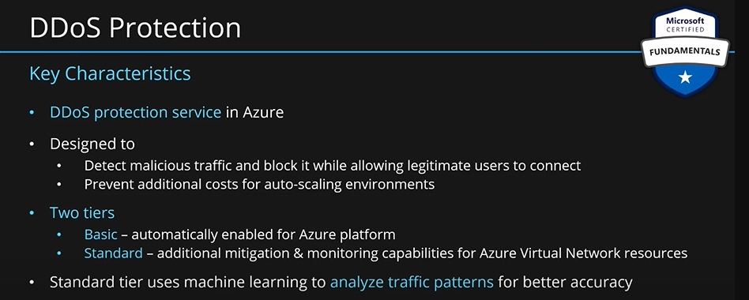

## Azure Key Vault.

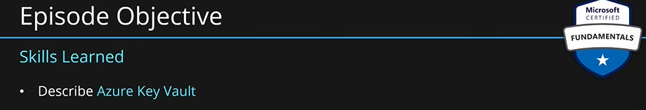

Secure storage for storing our secrets.

Let’s say we have a VM. This VM also has a disk. The disk contains a lot of our information. We will encrypt this disk. So, if someone gets a hold of this disk, they will not be able to read our data. This will be done through an encryption/decryption key. By default, azure provide these keys called **platform management keys,** but we can also provide our own key. All disks in azure are encrypted by default. These encryption keys are stored in azure key vault. So, azure key vault is a secure storage for disk encryption keys.

Another scenario is when you have a web application, and you connect to a DB from this web application. To connect to a DB, you need a connection string having server address, username and password. These are called application secrets. This sensitive information is also stored and managed in azure key vault.

There are plenty of additional SDKs. So, one can very easily integrate their existing applications with azure key vault. There are a lot of azure solutions which allow integration of key vault without writing a single line of code.

If your web application is serving content to the users in a secure way over HTTPS, So, over an encrypted channel through internet, you can create files called certificates. Certificates are complex objects for cryptography. They can be used encrypt traffic as it goes from web server to client. They can also be used for authentication. There are many more uses of certificates. Certificates can also be stored in azure key vault safely.

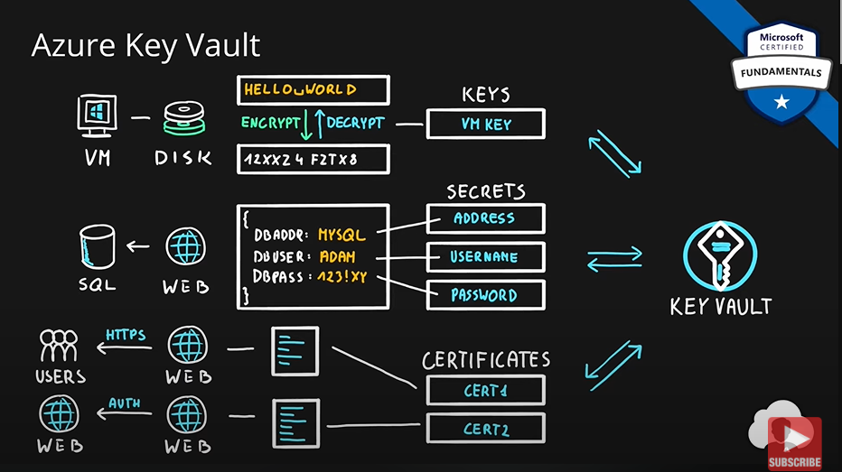

You can create as many key vaults as you want. You can create one key vault for every single application you want to manage your secrets.

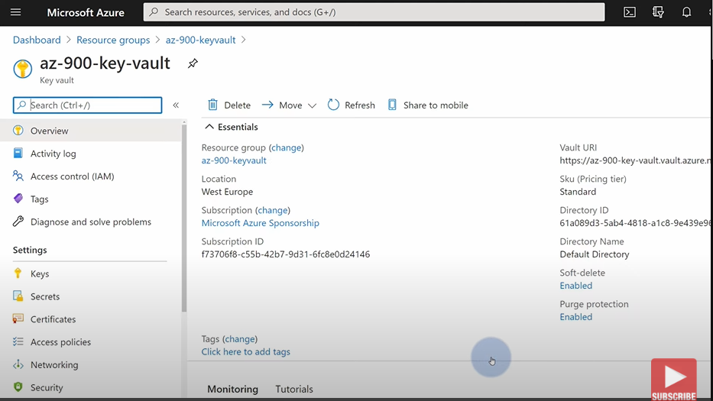

**In settings, keys, secrets, certificates, access policies, are the main ones.**

You can create a secret in azure vault. Then use this secret in other azure services such as logic apps etc.

Another advantage of using azure key vault is **centralization.** Secrets for all the services are stored at the same place. Let’s say you store the credentials for a DB server in key vault. Now, you want to connect to this DB server from your logic app and data factory. You can easily do that by making use of the same secret stored in key vault. If later you need to change the DB password, you can do that and it will be changed for all the applications using this secret.

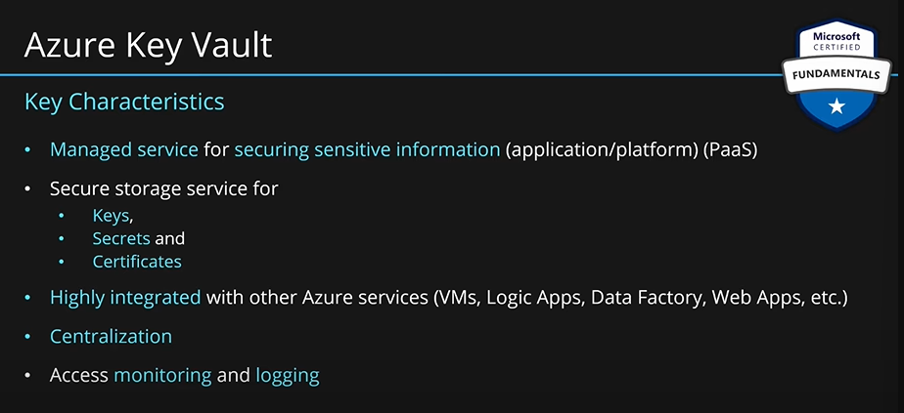

Everything happening inside key vault is logged and monitored. Who accessed which secret at what time and how many times. All these are logged.

## Azure Blueprint.

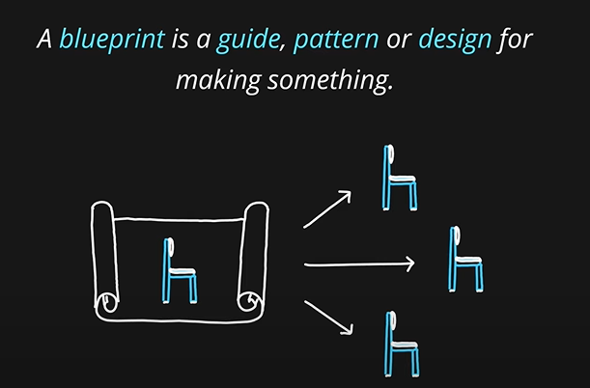

Let’s say you have a blueprint for a chair. Using that blueprint, you can create as many chairs as you can. All such chairs will be identical. Same principle applies for azure blueprint as well.

Let’s say we want to deploy pre-approved environment to deploy our web application. For this, we create a resource group, we assign roles to this resource group using role assignment. We will create resources inside this resource group such as SQL database and app service for hosting the web application. Also, we might want to apply some policies on this resource group.

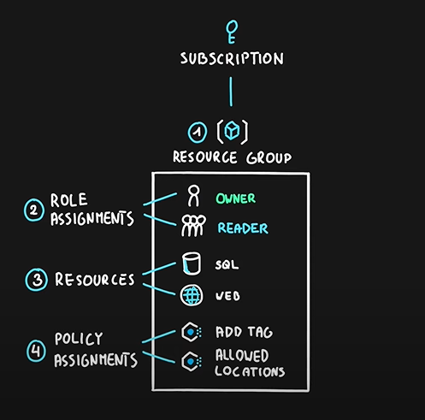

As your organization grows, all these things will grow as well. Now, if we want to replicate this whole scenario in another subscription or in the same subscription. We have to go through all of these steps again. We might make mistakes while recreating all of this again. This is where blueprints can help us.

We will take all of these components and put them in a blueprint definition. This might include role assignments, resource groups, resources, and policy assignments. Once a blueprint is created, we can deploy everything inside the blueprint at the press of a single button.

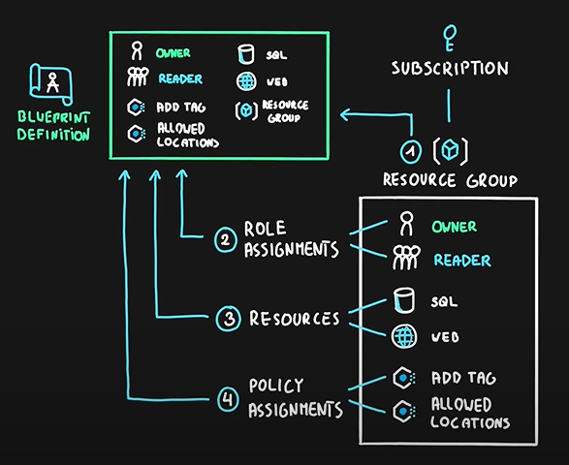

We can deploy blueprint definition by using blueprint assignment. We can do the blueprint assignment as many times as we want. This way we can replicate an environment as many times as we want.

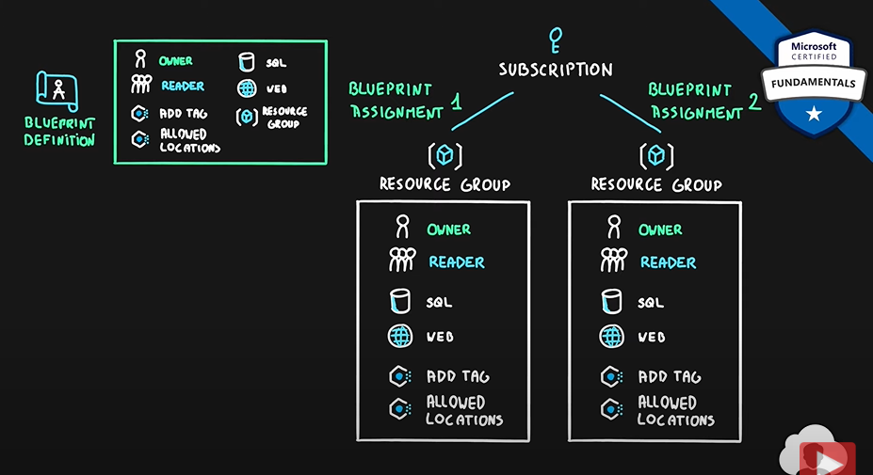

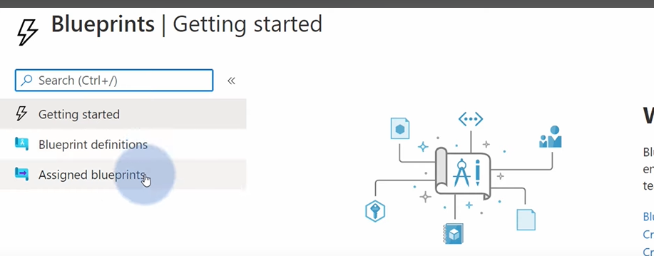

MS provides sample blueprints as well.

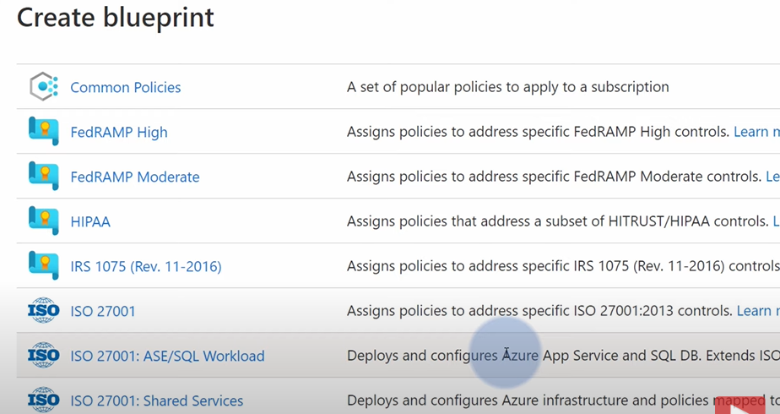

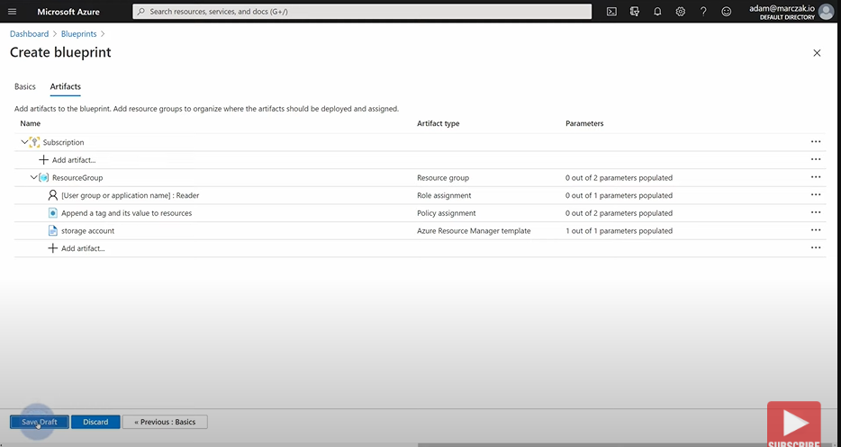

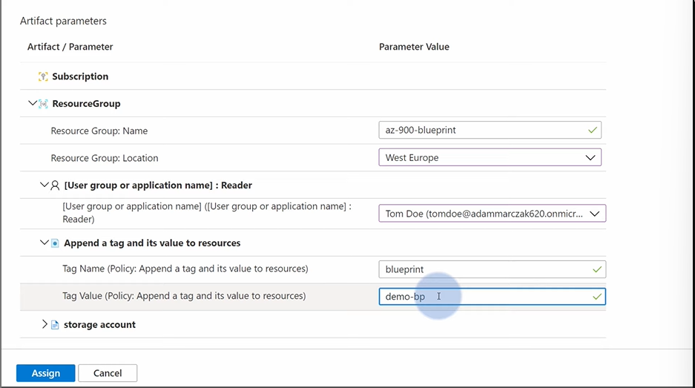

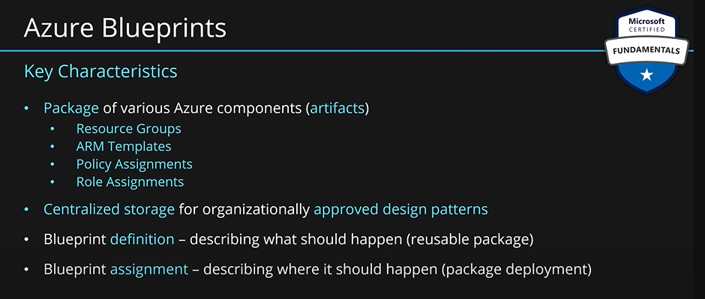

## Cloud Adoption Framework:

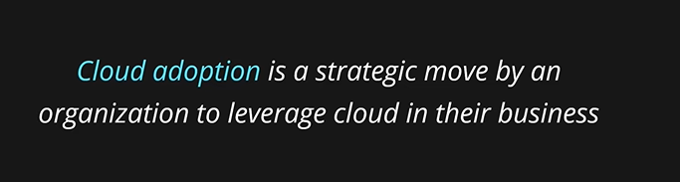

Adopting cloud can help your organization to build solution faster.

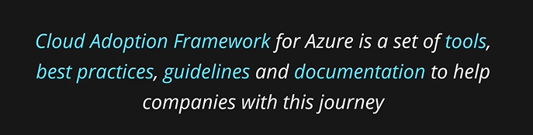

Cloud Adoption Framework has many stages. First stage is strategy.

**Strategy:**

1. **Motivation: Why move to cloud?** Meet with key stakeholders and executives of your company to document what are the motivations behind the cloud adoption. We might have **motivation triggers** here. Most common are:

* **Migration:** We might want to migrate to do **cost savings, reduction in complexity, operation optimization, increased business agility by having more flexible approach to manage infrastructure.**
* **Innovation:** We want to leverage the cloud and its features to provide some improvement to your company. Which could mean, **reaching a global scale, improve customer experience, create new products and services or disrupt new markets**. All of these are easier to do if you start using the cloud.

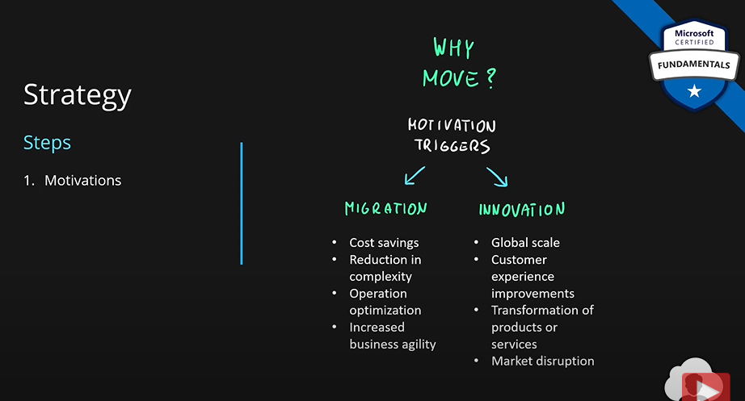

1. **Business Outcomes: What to measure? What would be your criteria for success of cloud adoption.** This must be defined, concise and observable outcome captured by a specific measure:

* **Revenue**
* **Profit**
* **Cost**
* **Global Access**
* **New Markets**

It is important that this factor can be defined, measured and tracked. To do all the calculations, you would want to meet with your business leaders from finance, IT infrastructure and application groups.

1. **Business Justification: What is my ROI?** Company wants to make money and it is important to track it. This step is all about that. You want to develop a business case to validate the financial model that supports your motivations and outcomes. So, this step used the two previous steps as inputs.

MS provides many tools which can help with building this financial model. CTO might want to use **azure TCO** **(Total Cost of Ownership).** This tool will tell you the cost of your current on-premises infrastructure. With **Azure Pricing Calculator,** you can estimate the monthly cost of your azure infrastructure. When you start deploying to azure, **Azure Cost Management** will give you full visibility of your existing resources and their cost.

Keep in mind these three tools used in business justification step. Might be asked in the exam.

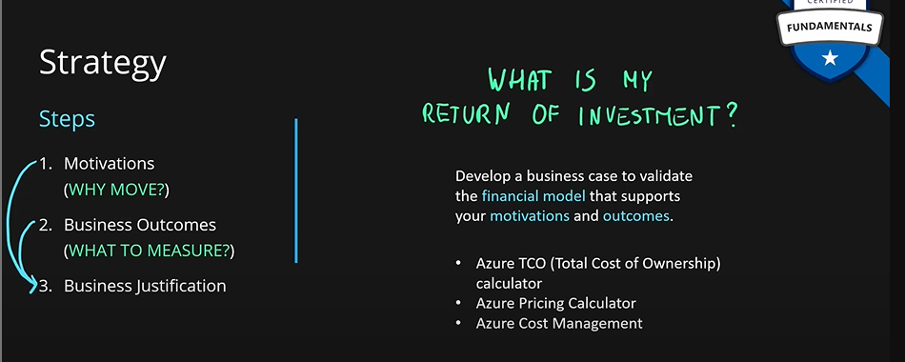

1. **First Project:** The first project will help you align your motivations and technical efforts. Two criteria to choose the right first project:

* **Business Criteria:** 
  + **Currently Operating:** A project that is currently being worked on in your company. This project must have a **dedicated owner**. This is important that the owner has **strong motivation to move to the cloud** and sees the benefits of the cloud. Engagement of the owner is crucial in every step of the process.
* **Technical Criteria:** Pick the project which has minimum number of dependencies and assets. Otherwise, it will take too long to make this project and will take too much time to validate your strategy.

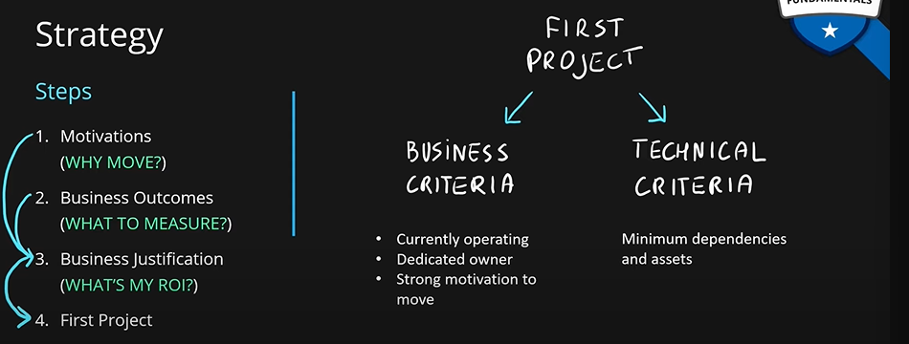

**So, in strategy our goal is to define business justification and the outcomes.**

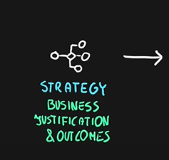

**Planning:**

1. **Digital Estate:** It is an inventory of assets. You want to review what you have in your company and what should you do with it. What **rationalization** is decided based on this five Rs of rationalization rule. So, each digital asset you have in your company, you need to assign an R to it.

* **Rehost:** We take existing application and move it to the cloud without any changes. This typically means move existing application into IaaS. So, we deploy the existing application into a VM, or a container.
* **Refactor:** Make small changes/refactor your application code base to that it can fit into a PaaS service. For example, if you have a web application running on your VM and this web application uses SQL Server, maybe with a little bit of changes we can fit this into an azure app service and azure SQL to take advantage of PaaS offering from azure.
* **Rearchitect:** You will need to make complex changes to your existing application. This will be used if you need to introduce new services in your application. For example, key vault is a very good service in azure. We want to use this in our application. We will rearchitect our existing application to take advantage of the key vault services in azure. Another reason for re-architecture is if your application strongly depends on the physical infrastructure which is on-premises. This might make your existing application incompatible with the cloud. Hence, you need re-architecture. So, we need re-architecture for new features or fix incompatibility.
* **Rebuild:** We create application from scratch. We might find that our existing application’s code is too old or too incompatible with cloud and fixing this incompatibility may be too costly or might take too much time. In this case, we will rebuild the application from scratch to take advantage of all the cloud features.
* **Replace:** You might have an existing application in your company which does a task. You might find that MS/Azure has a SaaS which does the same task. In this case, you may want to replace your existing application with this SaaS.

**So, go through all the projects you have in your company. Assign an R to each. Then make a plan out of it.**

1. **Initial Organization Alignment:** After the plan, you want to meet with key stakeholders and make sure everyone is aligned and every key person supports this adoption. You also map your people according to their capabilities. Who should be engaged when.
2. **Skills Readiness Plan:** Review your current skill sets in your company. Create a plan that will address the gaps because for cloud, you need a lot of new skills in your company across different teams.

**Once all these things are ready, put them in a cloud adoption plan. This plan will be used to manage the change across your digital estate, skills, organization and the processes.**

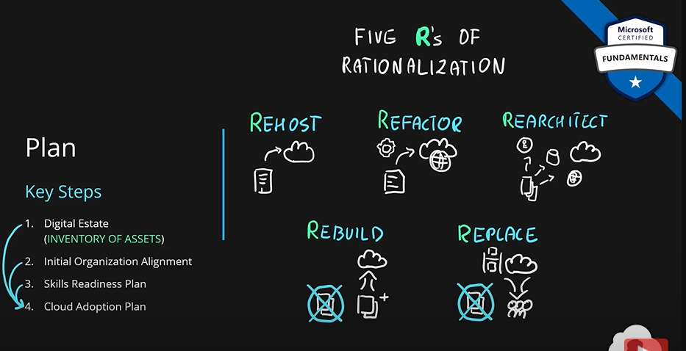

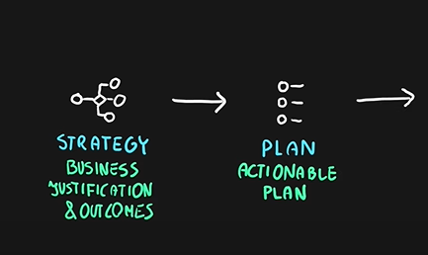

**Readiness:** It is all about preparing you first azure environment. Steps:

* **Azure Setup Guide:** Read azure documentation on how the initial environment should look like. You should be familiar with tools and approaches that will help you create this first azure environment. Also, you choose which type of subscription you should use which is best for your company.
* **Azure Landing Zone:** Your first azure environment is called landing zone. It will be completely created out of MS guidelines, and it will allow you to set up a code base for future improvements. It is advised to your infrastructure as a code approach, so, everything can be later changed, expanded, and updated. Everything is consistent and very easy to redeploy if needed.
* **Extend Landing Zone:** Now, extend your landing zone as per your organizational needs. This will allow smooth transition to cloud.

**Always check the best practices. Later, it is very difficult to change anything if you created a bad platform earlier.**

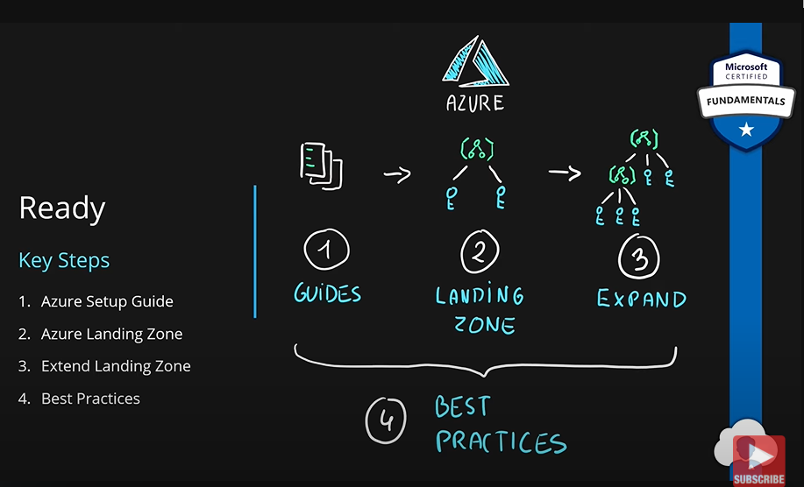

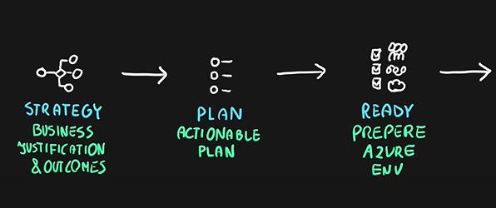

**Adopt:** All the previous steps were preparing us to move to the cloud, adopt is where we start doing that. Steps:

* **Migration:** We had migration in motivations. So, we have same in adoption as well.

1. **First Migration:** Migrate first project to the cloud. Read all the guides MS created for migration paths. Familiarize yourself with native tools and approaches in azure that will help you do the migration. There is also a **learning curve** associated with that.
2. After the first migration, you must make yourself familiar with migration scenarios. You will find that there are different workloads/scenarios that need to be migrated. For example, migrating VMs is completely different from migrating data services or web applications. MS provides many guides to help you with different scenarios.

Always use best practices for each tool you decide to use. These tools will accelerate other migrations in your own company.

Migration is very process heavy activity. So, keep in mind process improvement. It will take a lot of time to migrate everything into the cloud. How your current migration is going and how can you improve certain processes of your migration is very important for your future migrations.

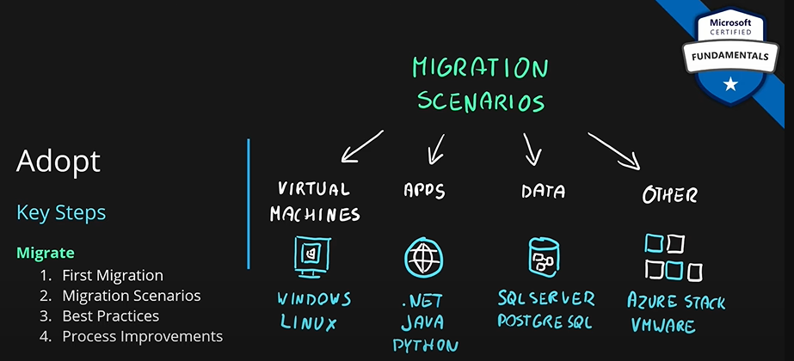

* **Innovation:** 
  + **Business Value Consensus (Value to Strategy):** It is a decision that you need to make on a technical solution and identify a hypothetical customer need and map it a business value that you can provide by building this solution. Then match it and map that value to your cloud strategy.
  + **Innovation Guide:** Here we decide on the tools that are available in the cloud to accelerate development of this solution and build this **Minimum Valuable Product (MVP).**

**Always use best practice. Your decisions will be solid foundation for your other applications.**

**Also, remember about process improvement. Make sure your customers and teams provide feedback. Azure DevOps or Github can help you with this.**

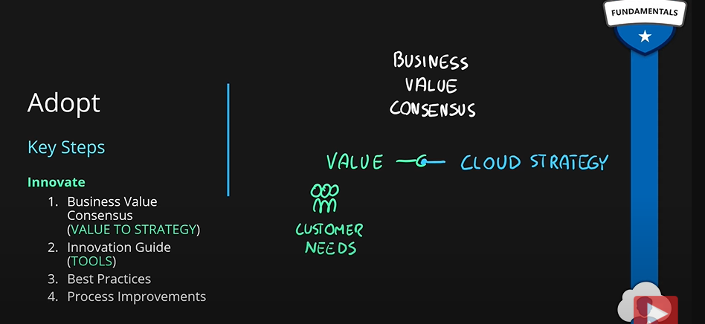

**In summary, adopt stage is about implementing existing plan and either migrating or innovating or maybe both.**

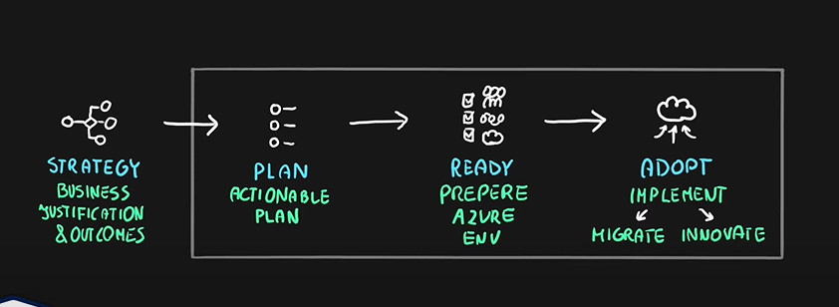

**Three stages of Plan, Ready and Adopt are the key stages that define cloud adoption according to cloud adoption framework. (Might be asked!). All other stages are supporting stages for these three stages.**

**Governance and Management:** These processes span across the above mentioned three stages.

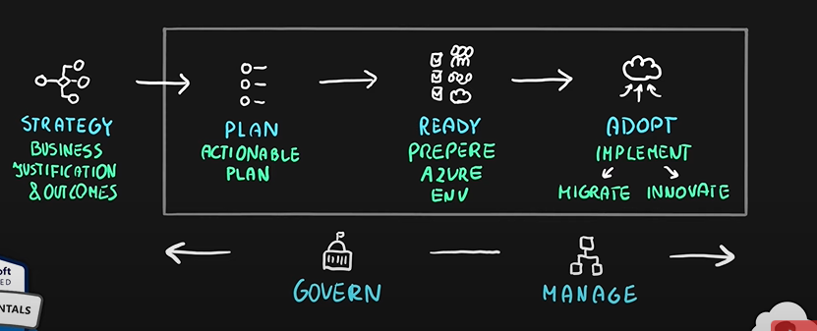

Steps:

1. **Define Governance Solutions:**

* **Business Needs:** Your solution must meet your business needs.
* **Agility:** So, you can easily adopt to the cloud. You don’t want to constraint yourself.
* **Control Risks:** Make sure your environment will stay compliant and stay secure at all times.

1. **Manage:** Cloud Operations:

* **Stability**
* **Cost of the platform**

Above two are needed to meet business commitments.

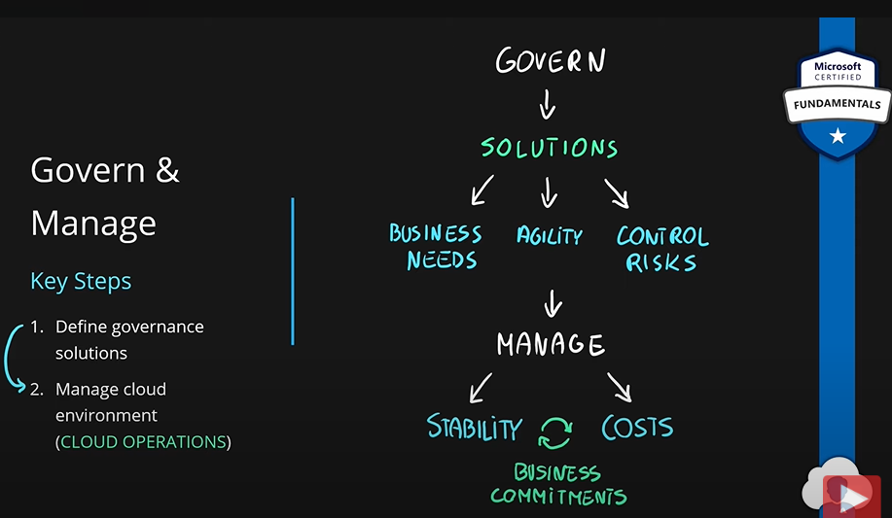

Governance: Environment stays compliant, is controlled and secured.

Manage: Ongoing operations and optimization of your current environment.

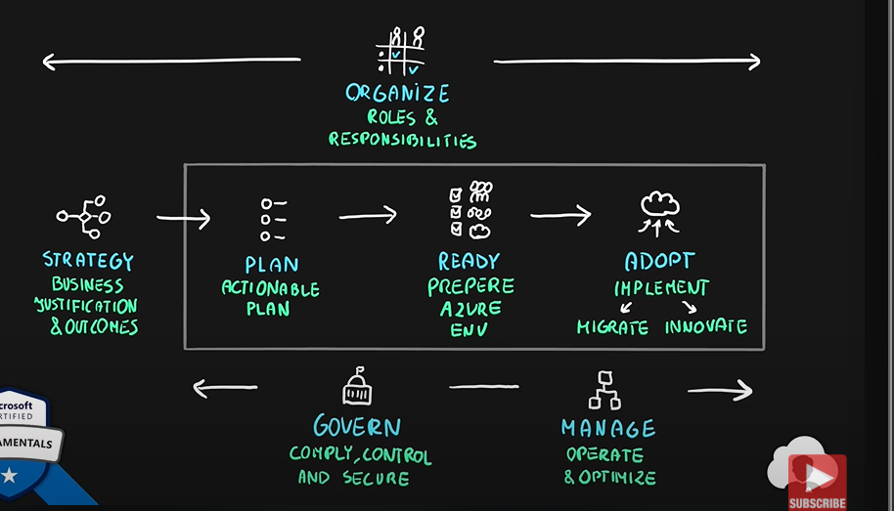

**Organize:** We have to make sure people are assigned proper roles and responsibilities. The cloud adoption will need a lot of teams and stakeholders. Everyone must know what to do.

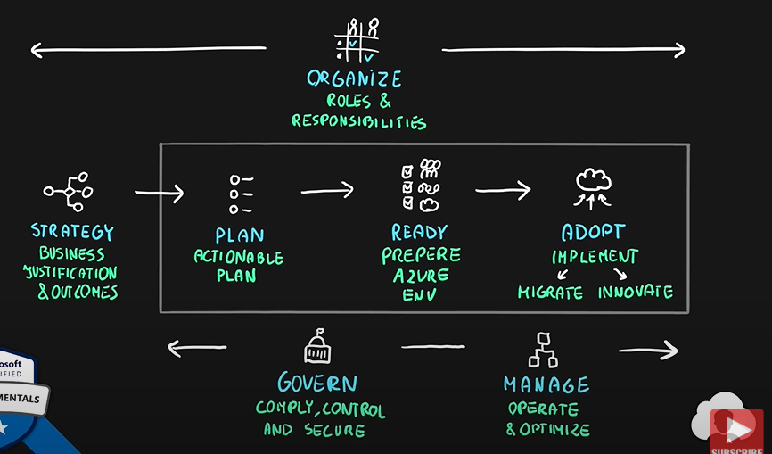

One of the ways to do it is to create **RACI matrix.** RACI means responsible, accountable, consulted, and informed. With this, every team will know what to do at what stage.

In the documentation of cloud adoption framework, everything is laid out nicely.

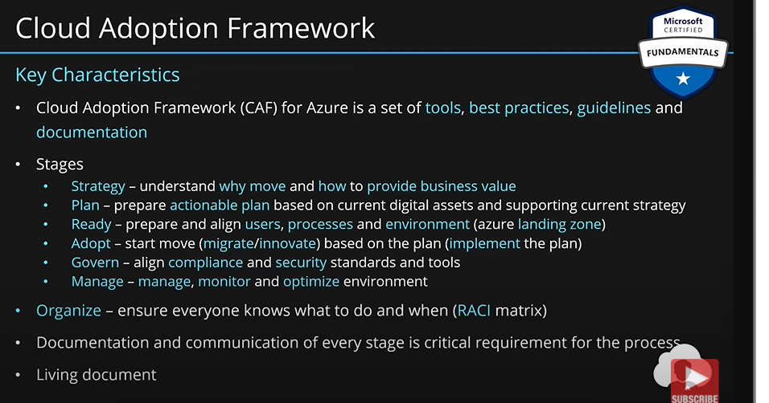

## Describe privacy and compliance resources.

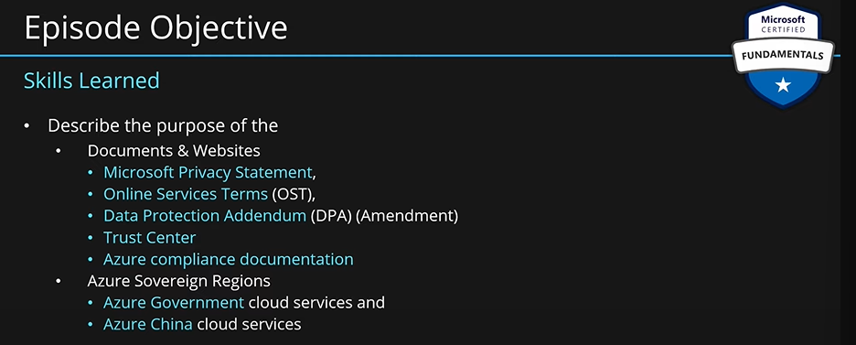

### Microsoft Privacy Statement.

1. **Information:** This document talks about the personal data. The collection of this data, the purpose of this collection and the usage of this collection across different services. This info is described in the context of following Microsoft offerings:
2. **Microsoft offerings:**

* **Services**
* **Apps**
* **Websites**
* **Software**
* **Servers**
* **Devices**

If you have any product from Microsoft such as windows, azure, office, surface phone, Xbox etc. All these services interact with your personal data. MS privacy statement describes what kind of information is being collected from each of these services, for what purposes and how its being used.

1. **Audience:** This document is designed for **everyone**.

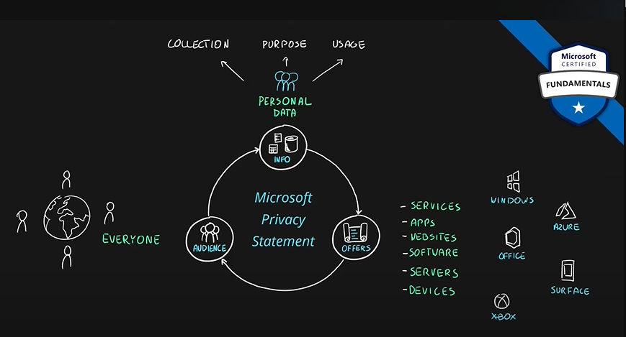

### Online Services Terms (OST).

1. **Information:** This document provides **legal** **agreements**. They call it **license** **agreement**. Previously called **usage rights.** These usage rights are described in context of online services provided by Microsoft. This doc tells you what you are allowed to do and what you are not allowed to do with these services legally.
2. **Offerings/Services:** 
   1. **Online Services:** Azure, Dynamic 360, Office 365, Bing Maps, or any other offering from Microsoft 365.
3. **Audience:** Since this is a legal document, this is designed for your organizational legal teams. Legal teams will make sure the application and the services that you provide follow those legal agreements.

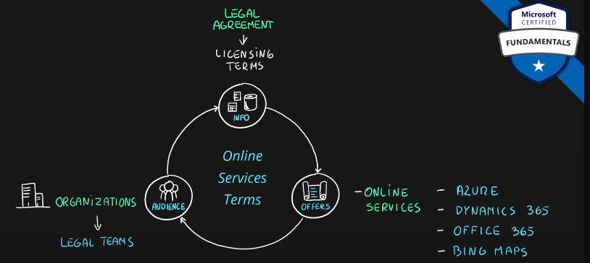

### Data Protection Addendum.

1. **Information:** This document describes the obligation between you company and MS. The information is given around the processing and security of your personal and customer data. It is similar to online services terms; it focuses on data and security of that data when using these online services.
2. **Offerings/Services:** 
   1. **Online Services:** Azure, Dynamic 360, Office 365, Bing Maps, or any other offering from Microsoft 365.
3. **Audience:** Legal and security teams.

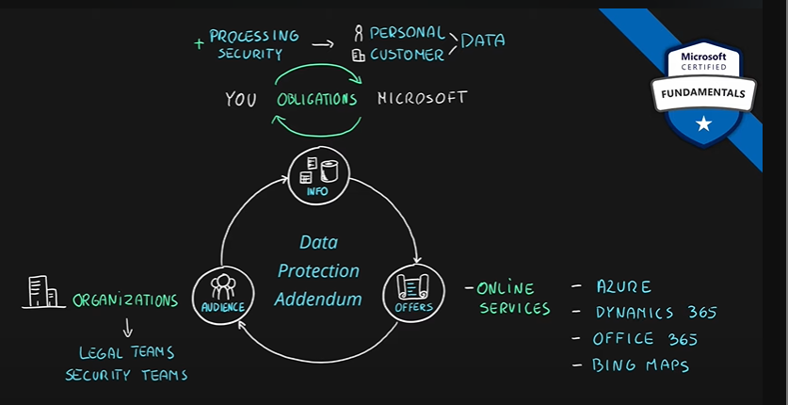

**Trust Center:**

1. **Information:** It is a website. All information regarding security, compliance, privacy, policies, practices around Microsoft services. A lot of helpful links, lists, information, checklists and a lot of online resources.
2. **Offerings/Services:** 
   1. **Online Services:** Azure, Dynamic 360, Office 365, Bing Maps, or any other offering from Microsoft 365.
3. **Audience:** Anyone.

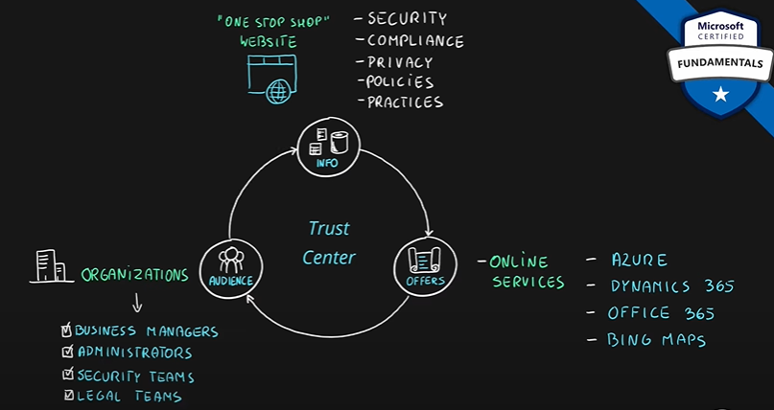

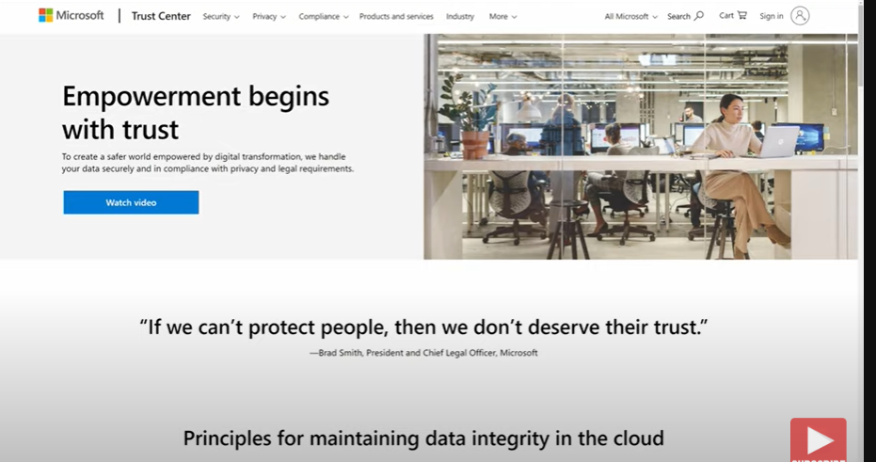

Let’s say we are building application for EU region. Now, we want to make sure our application is **GDPR compliant**.

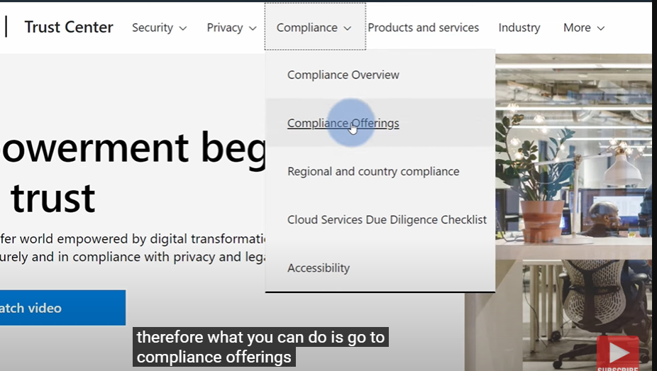

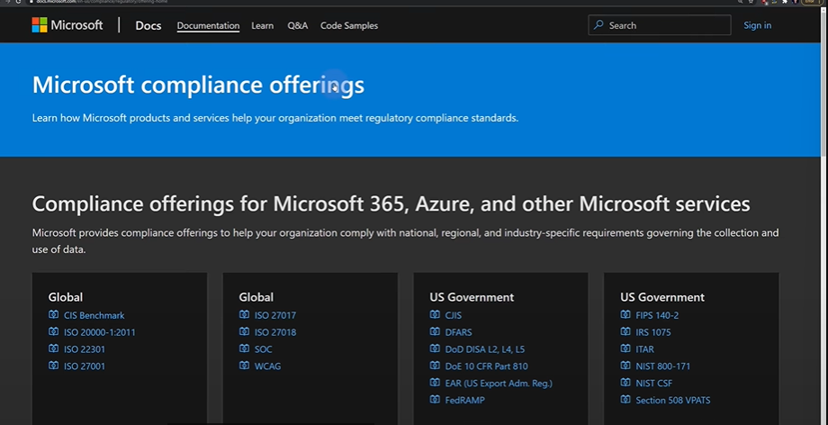

This will show you different products with different compliance.

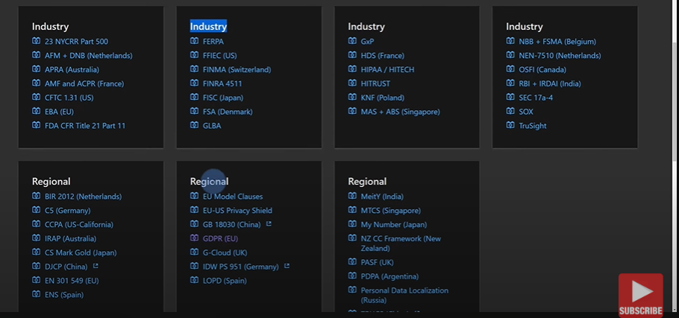

This also lists compliance offerings specifically for Azure. But we want our application to be GDPR compliant:

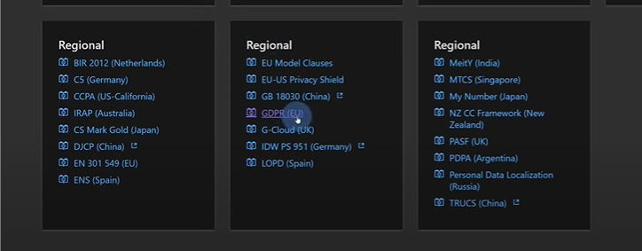

This will lead you to another documentation.

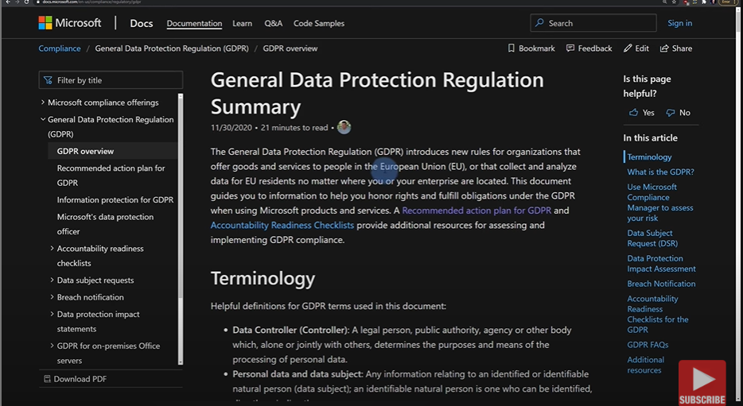

### Azure Compliance Docs.

1. **Information:** Provides **compliance** documents for azure. This is a dedicated portal for azure.
2. **National**
3. **US Government**
4. **Industry**
5. **Regional**
6. **Offerings/Services: Azure**
7. **Audience:**
8. **Business Managers**
9. **Administrators**
10. **Security Teams**
11. **Legal Teams**

**If you have a dedicated team for azure, they can use this document.**

**If you have multiple MS services, then you can use trust center.**

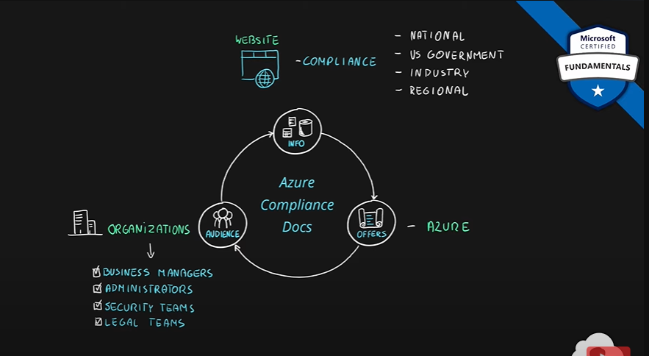

## Describe Azure cost management and Service Level Agreements (10-15%):

### Azure SLAs.

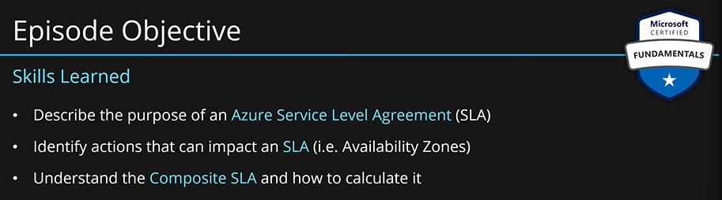

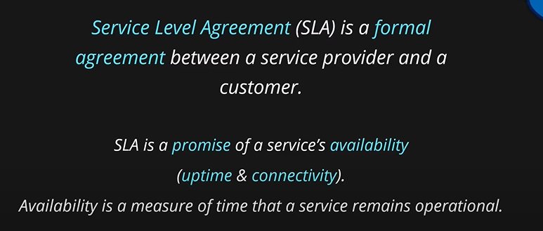

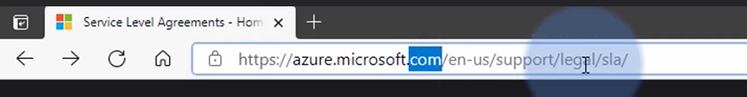

This page contains SLAs for all services by azure.

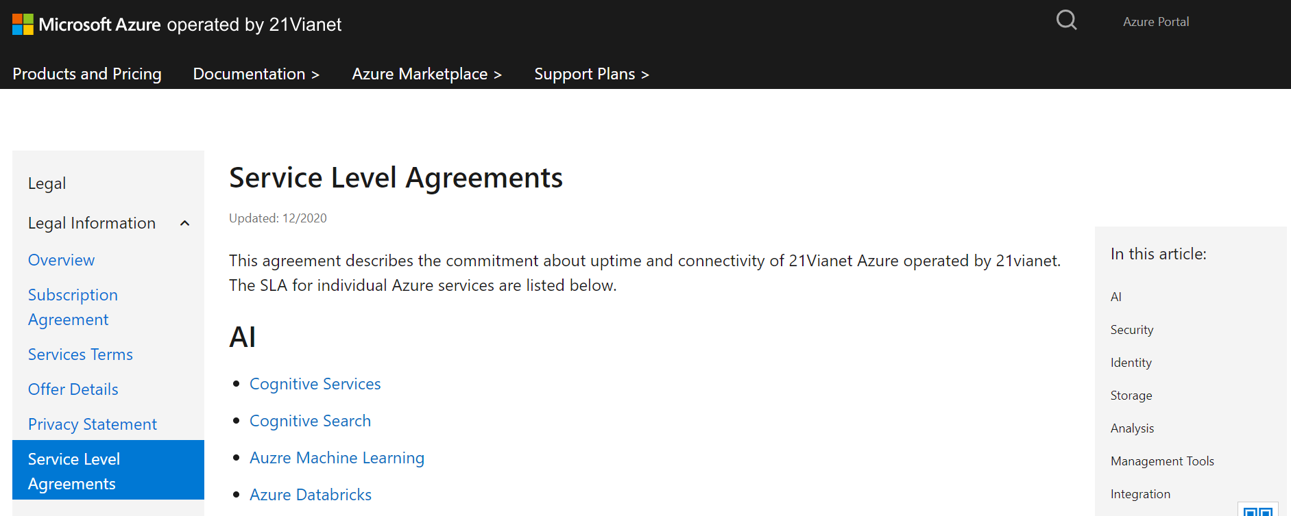

What kind of promises MS is making when it comes to azure SQL database.

Always check SLA details.

### Service Credit.

If MS is not able to meet the up time they advertised with the service, then they will give you service credits. These are usually in percentages such as 10%, 25% etc.

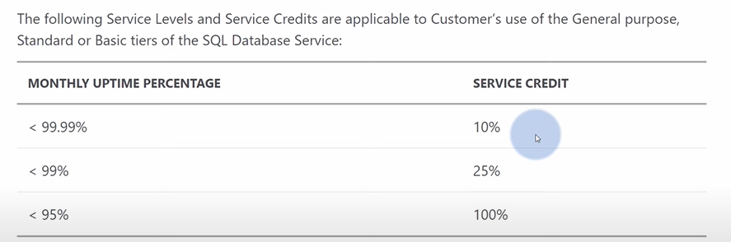

Service credit means a discount on the monthly bill of that service. So, 10% service credits on azure SQL DB means 10% discount on monthly bill of azure SQL DB.

SLA is a promise of availability calculated per month. Every service has its own SLA definition. Availability for most of service range from 99-99.999%.

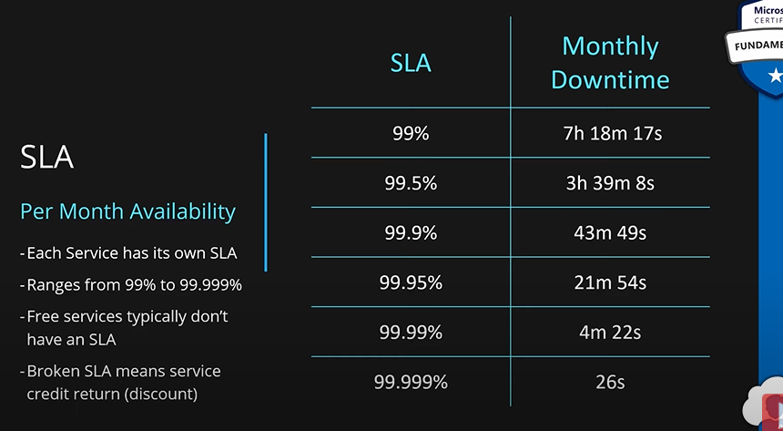

### Composite SLAs.

Combined SLA of all of your application components. If your application uses multiple components, then we can use the SLA of each component to calculate the SLA of the entire service.

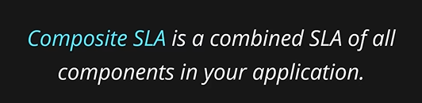

Let’s say we have a static website hosted in azure app service. SLA for azure app service is 99.5%. Since the application only has one part and that part has 99.5% SLA. Hence, whole application SLA is 99.5%.

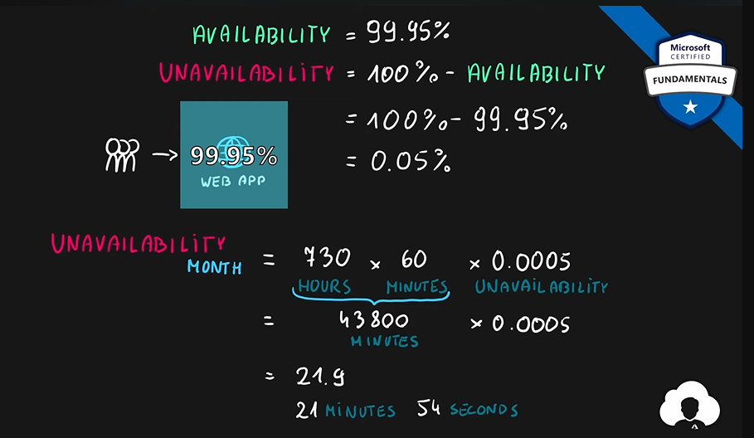

Let’s say our application has a DB and a web application. Web app service has out app server. Azure SQL DB has our DB. App service has 99.5%, Azure SQL DB 99.5% DB. For our application to be up, both of these services should be up at the same time. This is like **LOGICAL AND.**

To calculate the combined SLA, in this case, we will multiply, the SLAs of independent service since they are in a series:

Combined SLA = 99.95 * 99.95

= 99.9%

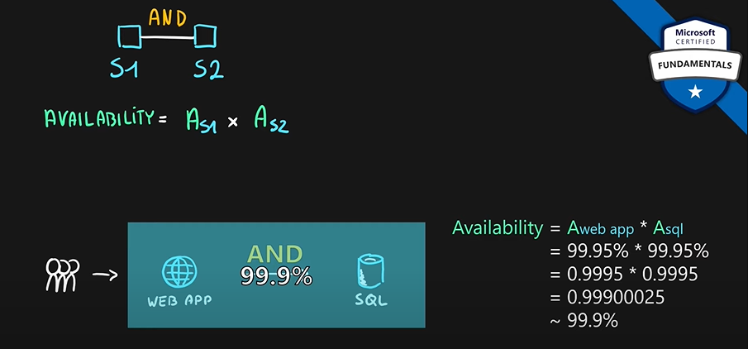

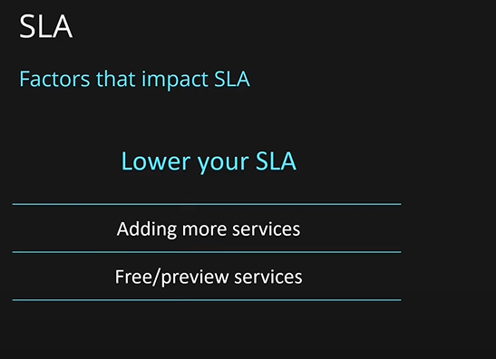

Let’s say our app looks like this:

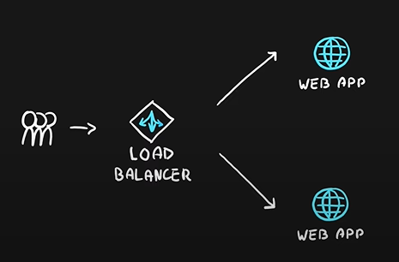

Since the web apps services are in parallel, this is **LOGICAL OR.** If either of these web services are up, our app will run. To calculate the availability:

Availability = 100% - (Us1 x Us2); s1, s2 are services in parallel

Availability = 100 – (99.5 * 99.5) = 99.9999% (Six nines of availability)

We also have a load balancer. Its SLA is 99.99%

These are in serial, so, we will multiply their SLA to get the overall SLA of the app.

Availability = 99.99 * 99.9999 = 99.98%

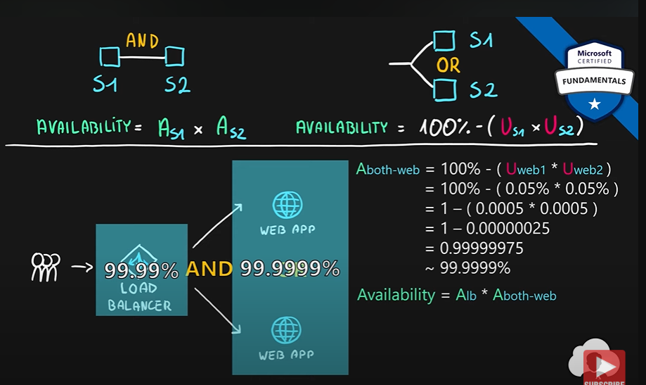

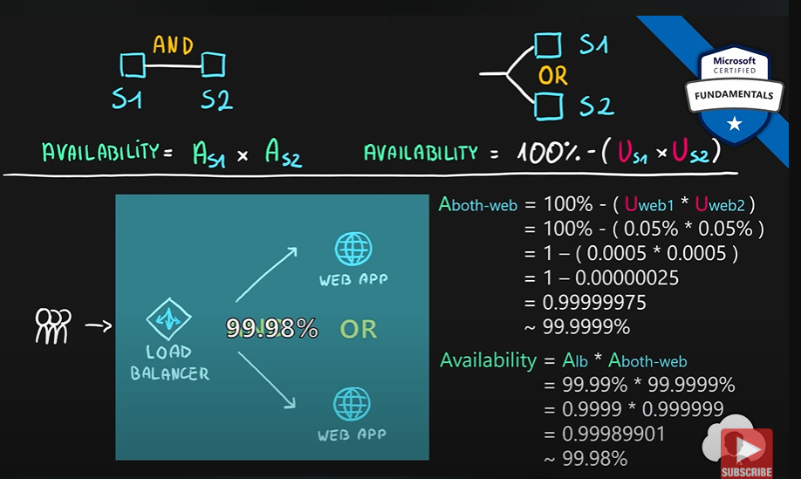

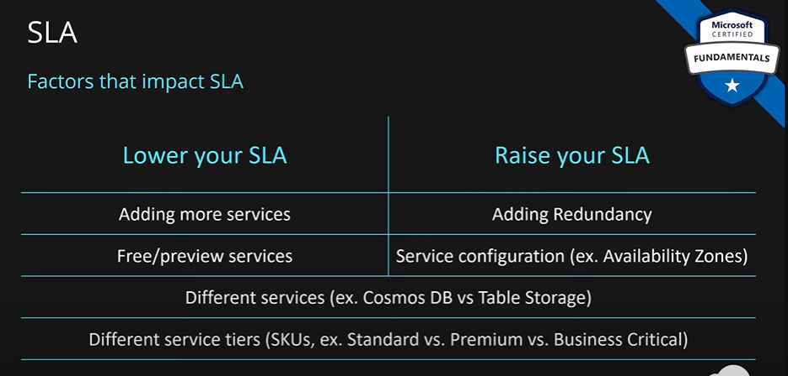

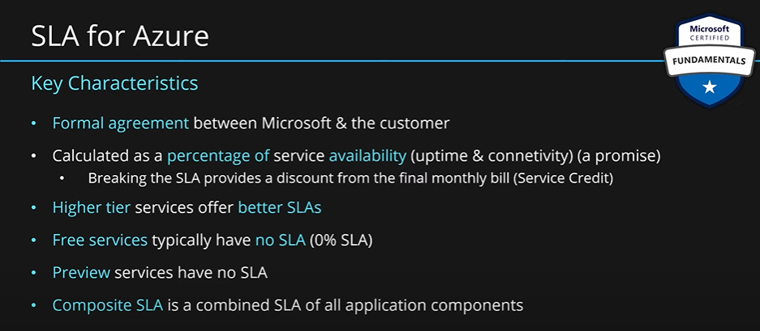

### Service Life Cycle in Azure.

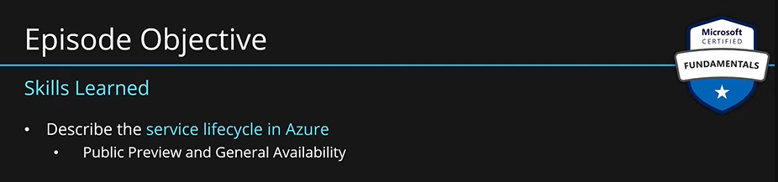

How is every azure service released for public use? The process of building that lifecycle follows a typical lifecycle just like SDLC.

It starts with **requirement gathering**, followed by development and testing. When the service is ready for public use, it is released. It is first released to public preview which is a preview version of the service. Most of the functionality is read, customers can use and test it. This stage is called **public preview.** It is like a **beta** for your service.

**Public preview is designed for:**

1. Customers can experiment with the service.
2. They can provide feedback.
3. MS will take that feedback into account and improve that service before the final release.

Now the service is released for public use. This time it is a **production ready** service. This stage is known as **general availability (GA).** People say the service has been GAed.

MS will continuously work and produce new features. These features might be released directly to GA but most often times they will also be marked as **public preview** too.

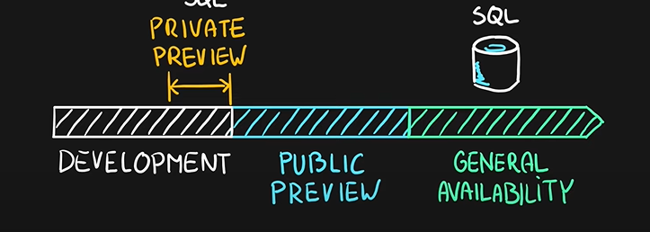

Some services which have been GAed very long time ago might have some features in public preview.

Apart from these there are also some internal stages such as private preview. It is only for a very narrow audience. This stage is covered by NDA. Typically, only people who needed this service like MS employees, MVPs and regional directors have access to these. These stage helps in proving the value of the service and test the service before releasing it to a wider audience.

**Key points about public preview:**

1. Very often they don’t have an SLA. So, we should avoid using these services for production level work.
2. Some services in this stage might not have support coverage.
3. Limited region availability.
4. Limited functionality.
5. Very often discounted prices.
6. Service direction may change.

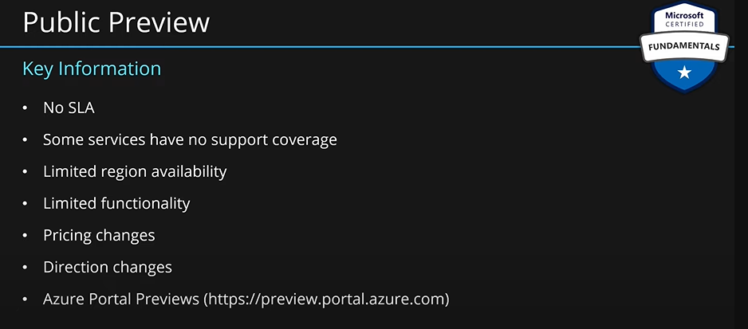

How to send feedback:

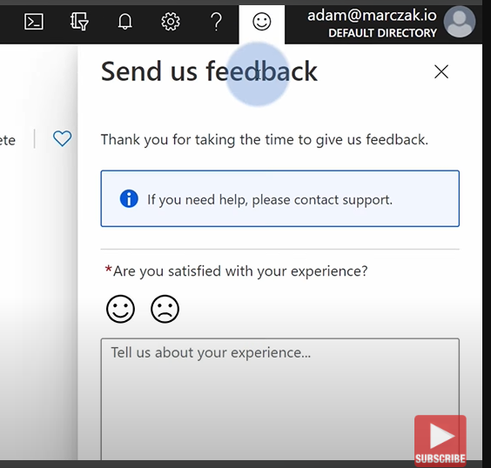

For updates:

